Lunabrite Introduces Special Glow Packs To Celebrate the Holidays.

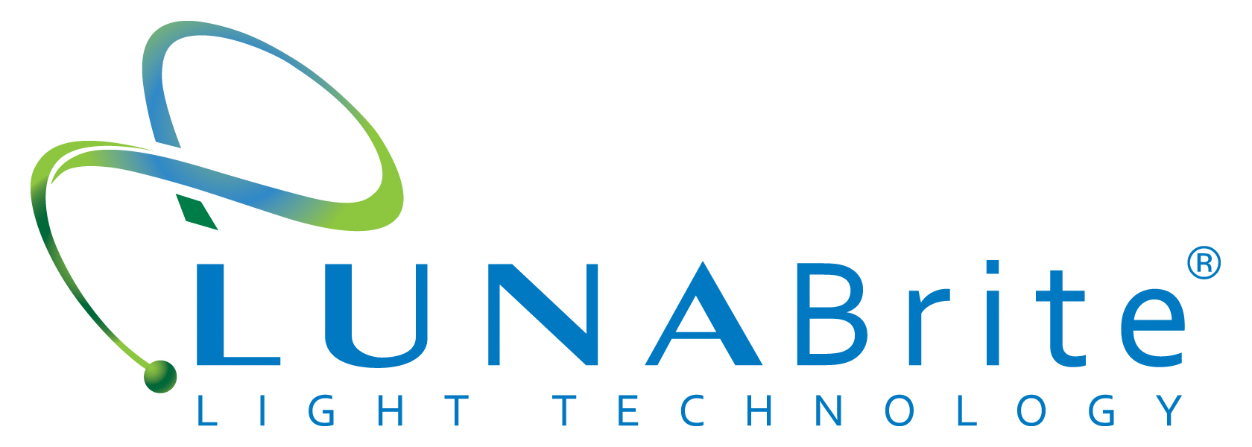

(1888PressRelease) Lunabrite Light Technology known for its high performance glow materials including patented glow rope and ribbon trim offers special Holiday packs

Lunabrite is offering 5 special limited-time Consumer Holiday Packs. The company, known for its innovation with high performance glow materials, has created a combination of its most popular luminescent products now available to the general public. According to company President, Barb Sommer, "People of all ages are attracted to the special magic of glow. Lunabrite is uniquely safe and easy to use for their most creative projects". She adds that the 2012 holiday packs will delight designers at all levels. "There is a growing consumer market for projects that can be accented or enhanced with Lunabrite glow including costumes, safe and environmental holiday lighting, and gifts that will keep giving long after the holidays are over."
Artists and crafts enthusiasts alike will welcome the special Holiday priced Lunabrite gift packs. According to Sommer, "As many Americans try to do more with less, Lunabrite understands that having affordable and creative gift making options is especially important during the holidays." Lunabrite has long been a favorite of the commercial market with applications that range broadly across industries including costume design, sportswear and outdoor spaces. "With Lunabrite holiday packs, consumers will get a chance to see how versatile our products are to personalize their projects" notes Sommer.
Lunabrite Ribbon is flat, extremely flexible, and can be easily applied to creative projects ranging from apparel design to outdoor products. The polymer material is ultra thin with a highest glow effect. Extremely light stable and lasting over many years, Lunabrite Ribbon offers a high impact glow for specialized night-glow effects, and is engineered to provide illuminating glow from dusk until dawn making it ideal for night safety applications. Four unique Ribbon packs are available. The Holiday Gift Pack features three popular colors and is available for $39.95. Individual single packs are offered at $29.95 each and are suitable for stocking stuffers. The packs feature three most popular nightglow colors: Limelight Green, Arctic Blue and Spring Green.
Patented Lunabrite Rope trim offers a round trim with a sewable edge for easy attachment ot curved or solid materials including fabric, plastic, wood and metal. The Holiday Rope Trim pack includes 5 popular glow trims including the newest glow, Lilac Sky for $29.95.
Lunabrite Light Technology is a leading eco-friendly lighting alternative across a variety of industries including: architectural, marine, apparel, footwear, safety, sports/fitness, outdoor recreation, and landscape. According to Sommer, "We are pleased to introduce the general public to Lunabrite. We are confident they will find our products both easy and fun, adding the illuminating touch of glow to their most creative ideas."
For more information, please contact the company at (973) 794-1062 or visit the company website.

http://www.lunabrite.com/

###

