Radon Awareness Month has started. Don't ignore the potential radon threat in your home. Call a radon specialist now

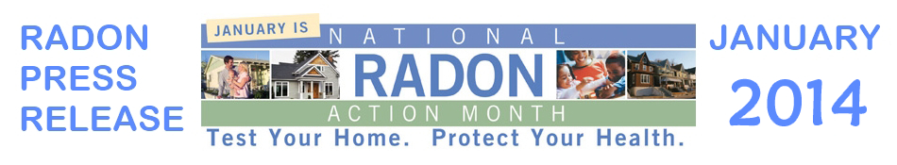

1888PressRelease - Call your radon specialist about national radon awareness month, and become informed about the radon gas threat, or visit www.radonmonth.org. Radon Gas is the second leading cause to lung cancer in the world. Ignoring this hazardous gas could be a potential risk to your life.

Every January, a Radon Awareness Month is held to teach home owners about some essential facts. According to Scott Jacka of SWAT Environmental, America's largest radon mitigation company "This is because radon is becoming an increasingly prominent problem for people." The Radon Awareness Month has been set up to warn people about these issues. During the Radon Awareness Month, home owners may want to consider how they can get linked up with expert advice as well. They can learn about how they can get their home defended against some of the different issues that people may face. Acquiring knowledge during Radon Awareness Month can help many people discover more about the solutions that they have available to them as well.
First, most home owners will want to concentrate on getting testing services for their property soon. SWAT Environmental says "This is one of the biggest reasons why the Radon Awareness Month was founded." The Radon Awareness Month would give people the opportunity that they need to contact a team in their area. Many companies will be advertising their services during the course of Radon Awareness Month. Home owners should take the opportunity to talk to providers during Radon Awareness Month to learn more information. This is part of the reason why people will be interested in securing the right service package for their needs. A brief inspection can actually protect the safety of people's homes as they go forward.
There are some repairs that people can have done during Radon Awareness Month. They may want to look in to how they can set up an air filtration system soon. Companies will be able to showcase the differences between these systems during the course of Radon Awareness Month. This Radon Awareness Month has been established to help people learn more about the different programs available to them. During Radon Awareness Month, people should think about how they can book the best possible service. These air filter systems are a vital component that people need to consider.
Owners will also want to think about getting a water filter set up during the course of Radon Awareness Month. Radon does have the ability to enter in to the water supply. Owners should be prepared to deal with this in some sort of fashion. They will be able to review their choices and get linked up with a company during Radon Awareness Month. These companies understand that owners want to make sure that they are using the best possible practices for these procedures. This is part of the reason why everyone will to research their options during the course of Radon Awareness Month.
It will be vitally important for people to think about how they can get a sealant set down during Radon Awareness Month. These sealants can be applied on the bottom layer of a home. If they are applied to the basement, then they will be able to block out some of the gas heading upward. During Radon Awareness Month, home owners will need to think about how they actually package all of this together as well. This will go a long way towards helping people learn more about the different options that they have. It can also just give owners peace of mind as they go forward.
Please visit www.radonmonth.org to better understand how dangerous radon gas is.
http://www.Minnesota-Radon.com

###

