Channing Crowder Signed As Spokesperson For Aventura Auto Gallery

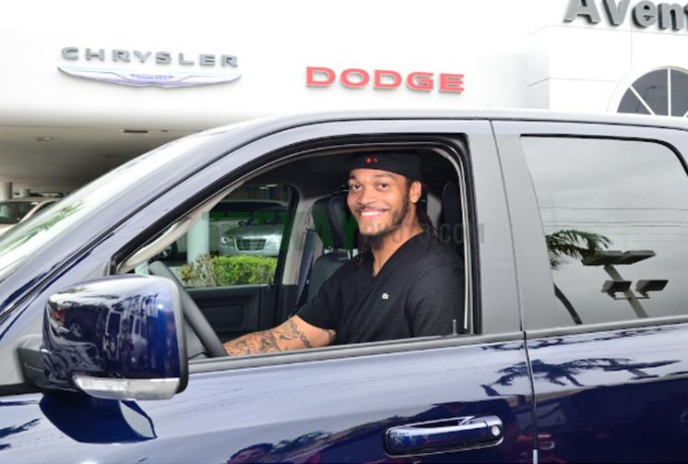

1888PressRelease - Coming from a career of tackling the most formidable opponents, former Miami Dolphin's linebacker Channing Crowder is now sacking the competition in the south Florida automotive industry.

Miami, FL - Crowder's newest position is with the team at Aventura Auto Gallery. Recently recruited and signed, Crowder is the new official spokesperson for the Aventura Auto Gallery, a premier automotive dealership in the Miami area. The Aventura Auto Gallery dealership proudly sells Honda, Chrysler, Jeep, Dodge and Ram brands. This former Miami Dolphin's linebacker has broken loose from the pack and is now a starter for one of Miami's best car dealerships.
When he's not on the radio co-hosting "The Kup and Crowder Show" on 560 WQAM, he's muscling through traffic in a new, fully loaded, Dodge Ram 1500 Quad Cab from Aventura Auto Gallery. Crowder knows a winner when he sees it; the Dodge Ram 1500 was recently ranked #1 in Full Size Pickup Trucks by U.S. News. Once named one of ESPN's All-American Linebackers, Crowder now sports the All-American Ram 1500 Pick-up truck. "I am thrilled to partner with Aventura Auto Gallery. The Ram 1500 that I'm driving is full of hard-charging power and has a smooth ride on the street. I'm used to playing on the defense side of the field, in this Ram truck, I feel like I'm always on offense!" Crowder says.
Channing Crowder spent his entire professional football career with the Miami Dolphins. He was drafted by the Miami Dolphins in 2005 NFL Draft. Before that, he played college football at the University of Florida from 2003-2004. Crowder is committed to making a difference in the South Florida Community. His charitable involvement extends from making public appearances to supporting local charities such as the Sun-Sentinel Children's Fund, and the Boy's and Girls Clubs of Broward County. As a spokesperson, look for Crowder to be featured in Aventura Auto Gallery advertisements and to make personal appearances.
"We are thrilled to have Channing Crowder as our spokesperson," Ralph Perkins Vice President of Sales and Marketing at Aventura Auto Gallery, says. "Crowder had an illustrious career in the NFL, he is a great addition to our team and we know he will bring the same winning spirit and drive to our dealership." The Aventura Auto Gallery is made up of Honda, Chrysler Jeep Dodge & Ram brands and is part of the Potamkin Automotive Group with 40 dealership locations. The dealership serves the Aventura, North Miami Beach areas.
With Crowder on the team, Aventura Auto Gallery will always have strong field presence in Miami.
Aventura Chrysler Jeep Dodge & Ram is located at 2198 NE 163rd St North Miami Beach, FL. For more information, call (877) 761-4059, or visit http://www.aventuracjdr.com.

###

