Name of Game | Basketball - Fun Sports Basketball Shooting Game For Kindle
Email | mary@rvappstudios.com
Publisher | RV AppStudios
Summary Description | Play this fun free Basketball game & see if you got the basketball skills to make baskets! Basketball is simple to play but hard to master. Play this fun arcade physics based basketball shooting game.
Size (MB) | 25.8MB
Version | 1.0
App/Game Category | Sports
App/Game URL | http://www.amazon.com/RV-AppStudios-Basketball/dp/B00BOTBGP4
Game Logo | 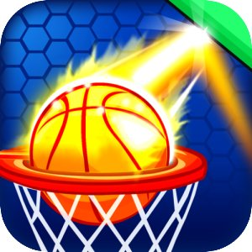
Price | $0.99
Languages | English
Release Date | 11/03/13
Full Description | Play this fun free Basketball game & see if you got the basketball skills to make baskets! Basketball is simple to play but hard to master. Play this fun arcade physics based basketball shooting game.  * Basketball Key Features *  - Amazing Basketball Animation & Sounds  - Beautiful HD Graphics  - Various Power Ups & Boosts  - Challenging Goals To Complete  * Multiple Game Modes *  - Classic - 60 Challenging Level  - Endless - Continue Till 10 Shots Missed  - Timed Mode - 1 Minute To Make Multiple Baskets  This basketball game includes different obstacles to keep you challenged and provides various power ups to make those hard to make baskets.  Basketball is a best basket shooting game, and will keep you entertained for hours. Whether you like to shoot hoops based on time, skill, or play our level mode you’re bound to have fun!  Why Play Basketball?  This is the perfect basketball game when you have a few minutes to spare. Shoot baskets at your own pace & see if you can complete all the challenging levels. Compete with your friends and see who is the best basketball player!  PLEASE NOTE: This app lets you purchase digital content using actual money. You can configure parental controls for in-app purchases, which will require your Amazon account password or a 4-digit PIN, by going to the Settings menu from within the Amazon Appstore.
Screen Shots | 