High-Risk For Radon In Colorado
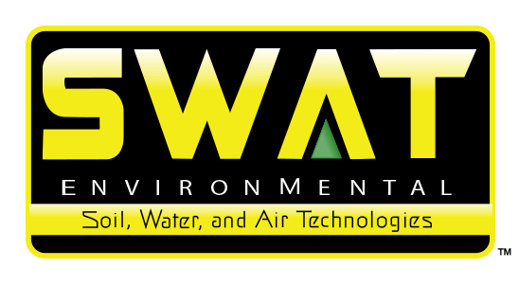

1888PressRelease - The Colorado Department of Public Health and Environment recently increased the risk level of 12 counties in Colorado. All 64 counties in Colorado are now considered high risk for radon exposure. The Colorado Department of Public Health and Environment decided to increase the risk levels of these 12 counties after reviewing the average radon levels throughout the state.

What Homeowners Should Understand Now That All of Colorado Is At High-Risk For Radon
The threat of radon in Colorado has been known for some time. Nearly all of the counties in the state have been deemed as having a high risk for radon. The recent news that the 12 previously moderate-risk counties in the state have been elevated to high-risk status underscores this problem. The risk of radon in Colorado is now uniform across all 64 counties. This announcement from the Department of Public Health and the Environment comes after data from 2005 was analyzed to update previous maps showing the levels of radon in Colorado counties. Coloradans needs to understand what this increased risk means and what actions to take in response.
Differences between Moderate Risk and High Risk
Three different levels are used to quantify the potential danger of radon in Colorado homes. Each of the 64 counties in the state receives a general rating. These rating translate into low, moderate and high-risk areas. The main difference is the concentration of radon as measured in homes. Radon in Colorado is appearing in high-risk concentration in anywhere from 50 percent to 70 percent of all homes. Although moderate ratings in Colorado counties were still dangerous, high-risk levels mean action needs to be taken immediately.
Radon and Homes in Colorado
Radon in Colorado enters a home through exterior openings and gaps. The gas comes from the soil. Radon in Colorado that makes it into a home will concentrate in different rooms over time. There is no way to tell if radon in Colorado homes is present or reaching dangerous levels without a detector since the gas cannot be seen or smelled. The announcement that radon in Colorado is now at dangerous averages in every single county means homes need to be tested quickly in order to determine if levels have increased in the years since the last statewide studies were performed in the 1980s.
Assessing the Risks of Radon
Radon in Colorado forms from small uranium particles in the ground and the exposed natural rock in the state. Radioactivity is the main thing to worry about with radon in Colorado. Living in a home with high levels of radon in Colorado can lead to lung cancer even in healthy individuals. Radon in Colorado has actually been responsible for anywhere from 400 to 1,400 deaths annually due to high exposure. Another risk is that radon can appear at any time in Colorado since shifting soil, weather and environmental changes can all increase the levels of the gas in an area or a home.
How Colorado Homeowners Should React
The first thing homeowners should do about radon in Colorado is have the house tested. This is important even if a previous test showed low radon levels. Radon in Colorado homes needs to be mitigated if it is above dangerous levels. Mitigating radon in Colorado usually involves consulting with professionals to develop a plan to reduce concentrations. Some forms of mitigation can lower levels inside a house by 99 percent. This is especially important in Colorado since radon levels are increasing. Testing and mitigation are the two actions homeowners can take right away in order to reduce the threat of radon in Colorado.
http://www.coloradohomeradon.com
###

