Name of Game | Best Flash Light - Best Flashlight App for Windows Phone 7
Email | mary@rvappstudios.com
Publisher | RV AppStudios
Summary Description | Get the brightest, fastest, and most feature rich flash light app in marketplace!!! The app uses camera flash light to give different effects and best brightness!
Size (MB) | 3 MB
Version | 1.0
App/Game Category | Tool & Productivity
App/Game URL | http://www.windowsphone.com/en-US/apps/537e5d95-dd83-4695-b09d-8ecb4f8741cc
Game Logo | 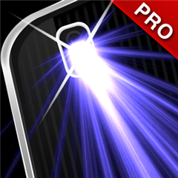
Price | Free
Languages | English
Release Date | 05/09/12
Full Description | Get the brightest, fastest, and most feature rich flash light app in marketplace!!! The app uses camera flash light to give different effects and best brightness! Plus you can setup a timer so that the light turns off after a few minutes as well. There are many ways you can use a camera light.  How can you use the camera light? Let us count the ways!  Set Light Timer - Light Up Room For Few Minutes.  Use it to open doors in low light  Find things in your purse  Find your keys in the dark  Read in the dark  Replace backyard bulb at night  Walking to your car at night  During a power outage  Hiking or outdoors  SOS During Emergencies  FEATURES:  Instant On Light When App Activates  Strobe Light Effect with Speed Control  Clap For Light On/Off Control  Flip Device On/Off Control  Multiple Tap Light On/Off  Energy Saving Light  Set Custom Light Timing
Screen Shots | 