OKPAY Company presents automated Debit Card Pre-Order service
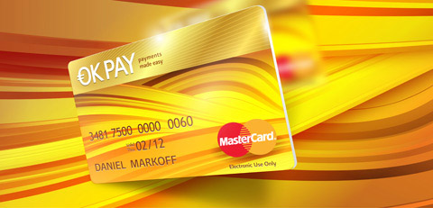
(1888PressRelease) OKPAY electronic payment system company is launching a new "Debit Card Pre-Order" service with full API support that allows merchants to present debit cards to multiple recipients e.g. organize a payout solution.
(1888PressRelease) A new service offered by OKPAY Company - "Debit Card Pre-Order" features a quick&easy process to create a mass debit card preorder and pay for it an advance for multiple recipients: business partners, colleagues or family members.
OKPAY officials report Debit Card Pre-Order contains of 3 simple steps: creating a formatted list of recipients, verifying your order and completing payment. The operation costs same as for a usual debit card order 15$ for a post delivery 70$ for a courier service multiplied on the number of recipients, no extra charges applied.
Recipients are getting OKPAY Debit Card absolutely free of charge.
API features can be used to automate the whole process of registration a client in the system, uploading required verification documents and pre-ordering a Debit Card.
About Company
OKPAY.com is a P2P and B2C web based payment system providing users with a virtual account that allows to easily load, send, receive and withdraw money as well as make purchases online. OKPAY is a widely spread electronic payments system and is among the world's leading eWallet providers with over 300 000 account holders.
Advanced eWallet system enables any customer to pay online conveniently and securely without revealing personal and financial data, as well as to send and receive money transfers cost-effectively by simply using an email address.
OKPAY Debit Card is irreplaceable for instant withdrawals and payouts as well as making purchases in both online and bricks-and-mortar shops with the MasterCard logo in more than 200 countries.
OKPAY payment network offers an access to the great number of payment options for businesses in over 200 countries within one integration.
https://www.okpay.com
Trackback URL:
www.1888pressrelease.com/okpay-company-presents-automated-debit-card-pre-order-servic-pr-330179.html
###

