Give A Fresh Start To Your Life With Muskoka Recovery Center
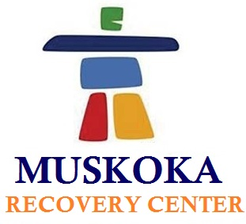

(1888PressRelease) Continuous abuse to any dependent substance whether it is drug or alcohol, leads to disaster. Thus, it is important to get rid of every addiction as soon as possible.

Addiction, the word itself defines its seriousness and complexity then one can easily understand about how the life of an addicted person would be. Thus, Muskoka Recovery Center is here to help such addicted persons who have lost every hope to get a sober life again. The rehab center is located in North Muskoka, covering almost 140 acres of picturesque area.
Muskoka Recovery Center offer personalized recovery program as per the need of every individual. To get the best recovery program, the counselors here prefer one-on-one session with every addict and understand the reasons of addiction, thus provide addiction recovery treatment accordingly. As a result of this unique approach of treatment, Muskoka Recovery Center is one of the best rehabilitation centers in Toronto.
Muskoka Recovery Center use state of the art technologies along with traditional treatment approaches like Reiki and massage to provide holistic services. Besides, following are the main accomplishments that make Muskoka Recovery Center, best rehab center in Toronto.
• Guarantee success result for every recovery treatment program
• The only rehab center in Toronto that provide effective treatment for Methadone addiction as well.
• This is the only rehabilitation center with highest success rate and lowest relapse rate.
• The only rehabilitation center that provides family program live online.
These are some of the accomplishments that make Muskoka Recovery Center stand out of the crowd.
Muskoka Recovery Center probably had been a thought only, if its founder and executive director, John wouldn't bear addiction issues. After his successful struggle against cocaine and alcohol addiction, he finally landed up with a thought of a rehab center. He started working on his dream project in the year 2005 and with three years of continuous hard work, Muskoka Recovery Center was ready to serve the addicts. Since then, the rehab center is setting new benchmarks for other rehab centers.
The credit for taking the rehab center to new heights goes to Muskoka Recovery Center staff members only. Qualified physicians, experienced addiction counselors, veteran therapists, and various others work together to provide reliable and effectual treatment programs. Under strict guidance and soothing ambience with resort-like facilities, the addicts at Muskoka Recovery Center recover faster.
To know more about the recovery treatment programs or any other services, contact us at 1-877-966-6887 or email at info ( @ ) muskokarecovery dot com dot
You can also visit the website at www.muskokarecovery.com

###

