City of Olathe, Kansas chooses NorthStar CIS and Customer Connect
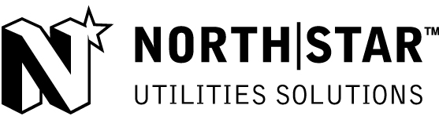

1888 Press Release - NorthStar Utilities Solutions is pleased to announce that the City of Olathe, Kansas has selected the NorthStar CIS and Customer Connect applications as its utility-billing and customer web engagement solutions. Using NorthStar CIS the division will drive its efficiency, integration, and continuing commitment to customer service.

OTTAWA, ON - NorthStar Utilities Solutions, a division of Harris Computer Systems, is pleased to announce that City of Olathe has selected NorthStar CIS (Customer Information System) as its utility billing solution and Customer Connect for web engagement.
The City of Olathe is a full service city with a population of 128,062. The Public Works Department provides potable water, wastewater treatment, solid waste pickup, curbside recycling, and storm water drainage. Additionally, the City bills many types of miscellaneous charges related to utilities such as yard waste carts, application fees, etc.There are several different types of customers for each type of service.It was important for the City to choose a comprehensive system to integrate billing for this diverse customer base. NorthStar Utilities Solutions offered the most desired system and integration services that match the requirements of the city.
As a core component of the City of Olathe's customer -oriented and future-proof solution, NorthStar CIS will provide the vital link to the integration of the utility's key applications. NorthStar CIS will provide automatic and easy access to actionable data across the entire CIS, and enable the utility to channel the free resources for other business goals.
NorthStar CIS is one of the most advanced utility billing system in the market today offering a wide range of features from setting up new accounts to viewing customer credit histories, customizable reporting tool, online payment of bills and much more. It is a platform independent, user-friendly solution that empowers utilities to provide smart tools and exceptional customer service to their customers.
"We wish to provide City of Olathe a solution that will meet and exceed their expectations. The solution will enable them to provide smart tools and exceptional service to their customers.
NorthStar is 100 percent focused on utilities and we are proud to be able to say that our CIS solution is the most feature rich CIS application on the market today. " Says Normand Daigle, Executive Vice President of NorthStar Utilities Solutions.
About NorthStar Utilities Solutions
NorthStar has served the utility market for more than 34 years. We deliver integrated solutions for utilities' billing, customer information, meter data management, and web engagement needs. More than 250 customers in North America, the Pacific and the Caribbean use NorthStar solutions to manage revenues, deliver superior customer service, improve efficiencies and reduce costs.
For more information on NorthStar Utilities Solutions and the NorthStar product suite, please visit http://www.northstarutilities.com
For additional information contact:
Ken Hayes
Vice President of Sales and Marketing
NorthStar Utilities Solutions
A division of Harris Computer Systems
256-686-1278 or 256-642-6368
khayes @ northstarutilities.com
sales @ northstarutilities.com
###

