Name of Game | Fun Math Tutor - Kids Special
Email | mary@rvappstudios.com
Publisher | RV AppStudios
Summary Description | Fun Math Tutor - Kids Special. Teach Your Kid's Mathematical Signs While Having Fun. Develop your Kid's Counting Skills. Fun Math Tutor is a fun educational based game for kids, specifically designed for iPhone/iPod Touch/iPad device. Help your kids have fun while also learning something new.
Size (MB) | 16.8 MB
Version | 1.0
App/Game Category | Games
App/Game URL | http://itunes.apple.com/us/app/fun-math-tutor-kids-special/id550940300?ls=1&mt=8
Apps/Games Logo | 
Price | Free
Languages | English
Release Date | 16/08/12
Full Description | Fun Math Tutor - Kids Special  ★★★ Teach Your Kid's Mathematical Signs While Having Fun ★★★  ★★★ Develop your Kid's Counting Skills ★★★  Fun Math Tutor is a fun educational based game for kids, specifically designed for iPhone/iPod Touch/iPad device. Help your kids have fun while also learning something new.  Teach basic math skills to your kids thru this fun & simple game. Play based on grade level for added fun and benefit.  ★★ Benefits:  ▲ Improved math skills! Kids will always learn more when they're having fun  ★★ How To Play:  ▲ Numbers are generated randomly at the bottom of the screen. Move the wooden spike on top and pop the required balloons. Anyone can learn and fun to play when you have a few minutes.  ★★ Different Levels:  ✓ Easy  ✓ Medium  ✓ Hard  Fun Math Tutor will provide hours of fun, entertainment, & education all in one. What are you waiting for, download this exciting new game today!
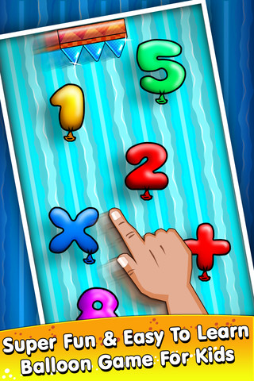  Screen Shots | 