Do-it-yourself-invitations.com Announces Handmade And DIY Wedding Invitations Contest And Giveaway
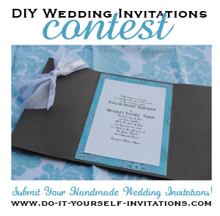
(1888PressRelease) Do-It-Yourself-Invitations.com To Host a Handmade Wedding Invitations Contest and Giveaway, sponsored by several Etsy.com Crafters and Artists.
Boston, MA-NH (1888PressRelease) - Do-it-yourself-invitations.com, a popular online resource for paper crafters and DIY bridal enthusiasts, announced the kick off of their annual Handmade DIY Wedding Invitations Contest. Visitors are offered a chance to win prizes offered by several Etsy.com Wedding Artisan shops, including a custom couture wedding album and guest book by artisan Shelby Specht of Specht Couture, an calligraphy package offered by Angelique Ink Design Studio, and a couture bridal accessory package from Avenue C Bridal.
To kick off this effort, Do It Yourself Invitations has partnered with several popular blogs where readers will be asked to enter their handmade wedding invitations with photos and a breif description for a panel of experts judges to pick their top three winners. This panel of judges will be made up of bloggers, Kymora of BecomingtheMrs.com, Jessica Bishop of Thebudgetsavvybride.com, and Lauren Donaldson of LaurenEliseCrafted.com and featured DIYer on Emmaline Bride.
The contest will also include a giveaway picked from a random drawing of all contestants. The winner of the giveaway will receive a custom designed bridal invitation map to accompany their wedding invitations or for out of town guest gift bags.
"This is such a great opportunity for many of us small business owners to band together and get the word out about our products and services." says Delilah Hatch, owner and editor of Do-it-yourself-invitations.com. In her own words, budget friendly wedding invitations are her specialty. "With the economy on the down turn and weddings costing as much as they do, many brides are looking for ways to cut costs. Making handmade invitations is just one of them," Delilah explains. "I wanted to host a DIY invitations contest to give these brides an outlet for showing off their great work, but also with the focus of inspiring each other on their journey."
Do-It-Yourself-Invitations.com is an invitations and card making website that has soared in readership since its launch in Late 2006 and is ranked among the top 1% of all websites for traffic according to Alexa traffic rankings. Hatch believes the popularity is in part due to a combination of the economy and DIY bridal trends. "The online community of DIY brides is exploding right now. Whether they have financial reasons, r are creating items to fit in with their unique style sense, more brides are turning back towards making items themselves."
The Handmade Invitations Contest runs through April 30th, 2011, giving brides plenty of time to finish up projects.
To view current entries, for more information or to enter the contest, please visit http://www.do-it-yourself-invitations.com/contests.html
Trackback URL:
http://www.1888pressrelease.com/do-it-yourself-invitations-com-announces-handmade-and-diy-we-pr-276406.html
###

