Muskoka Recovery Center- To guide your way to recovery
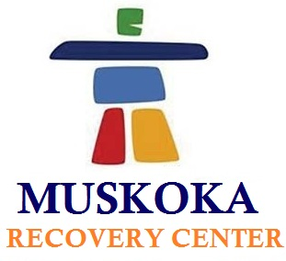

(1888PressRelease) Addiction whether it is of alcohol or drug or any other thing, leads your life towards end. However with Muskoka Recovery Center, recovering from addictions has become simple and easy.

(1888PressRelease) Muskoka Recovery Center of North Muskoka serving people to get rid of addiction with effectual and countable recovery treatment programs. With highly skilled and generous professionals, who are expertise in their respective areas, we provide individualized treatment plan. As to design this personalized treatment program, our experts proffer thorough counseling sessions and understand the reasons, needs, areas of improvements of the addict. At Muskoka Recovery Center, we keep motivating our patients with educational programs and latest technologies towards getting a healthier, safer and happier life again. Being a leading name for rehab center in Toronto, we provide recovery treatment plan for almost every kind of addiction including drug, alcohol and Methadone.
Till today, thousands of addicts as well as their families have been successfully recovered from addictions with Muskoka Recovery Center. As a result, we have highest success rate and lowest relapse rate in town. Muskoka Recovery Center is a modern rehab center having expertise in serving different types of patients at different stages of addiction. Furthermore, with the usage of state-of-the-art technologies, we are creating new and improved techniques of recovery to reach on exceptional heights of success. Besides as a result of enhanced and innovative addiction recovery treatment approaches, Muskoka Recovery Center has created a benchmark for other rehab centers.
With harmonious surroundings of over 140 acres in North Muskoka, Muskoka Recovery Center offers reliable and result-oriented recovery treatment plans. In 2005 John, the Founder and Executive Director of Muskoka Recovery Center have started designing the model for a unique rehab center. After three years of continuous hard work and deep research, Muskoka Recovery Center came into subsistence. Moreover, Muskoka Recovery Center offer resort like amenities Such as indoor pool, lounge, gym, etc. to make the recovery treatment comfortable as well as faster.
As to maintain the recognition, the professional staff at Muskoka Recovery Center always stands on their toes to serve the addicts with best possible assistance. Specialized physicians, counselors, psycho-therapists, spiritual health counselors, and more veterans are the part of our esteemed staff at Muskoka Recovery Center. With all expertise physicians, peaceful ambience and effective treatment plans, we are proud to be the leading drug and alcohol rehabilitation center in Canada.
To get more information or in case of any query, contact us via email at info ( @ ) muskokarecovery dot com Or call us at 1-877-966-6887
http://www.muskokarecovery.com

Trackback URL:
http://www.1888pressrelease.com/muskoka-recovery-center-to-guide-your-way-to-recovery-pr-411476.html

###

