Name of Game | Best Secret Browser HD Pro
Mail | mary@rvappstudios.com
Publisher | RV AppStudios
Summary Description | Surf The Web Privately, No One Will Be Able To See Your Surfing History. This is the ideal app for you if you have to share your device with others or have an extremely nosey family or friend. You no longer have to worry about them opening up Safari and seeing the phrases you've searched or places you've visited.
Size (MB) | 12.4 MB
Version | 1
App/Game Category | Entertainment
App/Game URL | http://itunes.apple.com/us/app/best-secret-browser-hd-pro/id508713907?mt=8
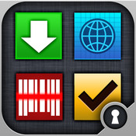
Logo
Price | Paid
Languages | English
Release Date | 23/07/12
Full Description | ★ Surf The Web Privately, No One Will Be Able To See Your Surfing History ★  This is the ideal app for you if you have to share your device with others or have an extremely nosey family or friend. You no longer have to worry about them opening up Safari and seeing the phrases you've searched or places you've visited. Your surfing history is yours and it's private. Now keep it private with Best Secret Browser.  Protect Your Privacy With Best Secret Browser HD Pro, you can now surf the web without others seeing where you've surfed. The app is password protected so no one will be able to access your surfing history.  Features:  ✓ Supports Multiple Tab Browsing  ✓ Easily Clear Cookies  ✓ Store & Clear Bookmarks  ✓ Easily Delete Surfing History  ✓ Browse Site With Full Screen  ✓ Customize Font Size Within Browser  ✓ Email A Photo Of Intruders With Details [Date, Time and Location]  ✓ Break In Attempts By Intruder Displayed On Icon  ✓ Ability To Clear Security Log  ✓ Supports Two Advance Security Lock Technique  ▲ Password Lock  ▲ Pattern Lock  Best Secret Browser even logs when someone tries to access your browser and enters an incorrect password. Log history will display successful logins, failed logins, pin change and more. Not only is your browser safe and secure to surf but you can even catch others trying to access it.  ★ The Only App Your Will Need To Secretly Hide Where You Surf & Sites You Surf From Other People! ★  ★★ If You Like The App Then Please Support Us By Reviewing The App ★★
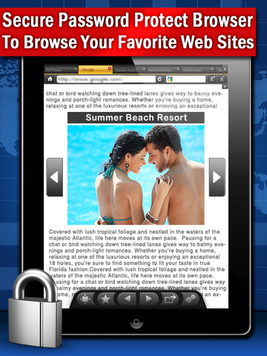  Screen Shot | 