Alcohol Server Permit Classes Online For 43 States
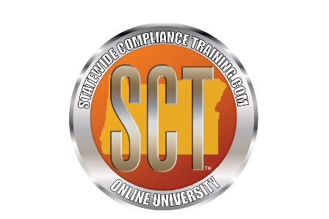
(1888PressRelease) Several states require you to take training and get a server or service permit to sell and serve alcoholic beverages. Statewide Compliance Training, LLC has just launched a new website portal to make online training available in 43 states. Almost all of their server permit classes are a mere $25.00.
(1888PressRelease) - Statewide Compliance Training has launched a new website http://www.servicepermits.com. The site is their newest portal for people working in the liquor industry with online training classes to obtain a server permit which is required by many states in the U.S.
Alan Espasandin, CFO of Statewide Compliance Training says "Our online training gets rid of the need to find an instructor and attend classroom instruction, now the student can take the server education course in the comfort of their own home."
Several states require any person who sells or serves alcoholic beverages to obtain a "Server" or "Service" permit. Without a valid service permits the employee can face large fines if caught selling alcohol. Their employer also may face fines by the liquor board in their state. Every state's requirements are a little different so Statewide Compliance Training has provided alcohol industry employees with 43 different state certified classes to choose from.
"States also have different requirements on who must have a permit, for instance, the State of Oregon through the Oregon Liquor Control Commission's regulatory authority require any person who "Sells, Serves Alcohol' OR 'Anyone who Manages employees who sell and serve MUST have a 'Server Permit.'"
The classes offered are for employees who sell alcoholic beverages for both on-premises and off-premises consumption. So check your local state laws if you work or are thinking of working in the liquor industry to see if you are required to have such a permit; then go to http://www.servicepermits.com to take a convenient online course without all the hassle of scheduling a class or finding a trainer.
"We also have an online class that will help servers and bartenders get larger tips. It's all fun and very informative training that I highly recommend to anyone working as a server" Said Darrin Taylor, CEO of Statewide Compliance Training.
Statewide Compliance Training will be adding more states to their online courses. They encourage you to check back with them soon for Oregon and Washington server training. If you wish to find out more you can find the company site at http://www.sctuniversity.com.
The online training is offered by Statewide Compliance Training and powered through their ongoing relationship with 360 training.
Trackback URL:
http://www.1888pressrelease.com/server-service-permit/online-training-alcohol/alcohol-server-permit-classes-online-for-43-states-pr-248477.html
###

