Canada Welcomes The Addiction Canada Treatment Network
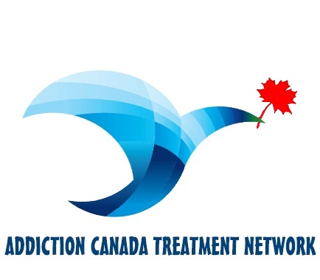

(1888PressRelease) The attention to the disease of addiction plus the utmost in recovery resources combined for the absolute very best in Addiction Treatment.

The Addiction Canada Treatment Network is bringing addiction recovery to new heights. With the help of absolutely every recovery tool available, families and loved ones can rest assure that addiction can be conquered or at the very least put into remission.
Addiction Canada Treatment Network is a complete combination of individuals coupled with the expertise in battling addiction and in addition offering a complete Addiction Solution when others are merely providing a place to dry out or get abstinent.
The Executive Director of the Addiction Canada Treatment Network says " people suffering from addiction shouldn't have to be made to suffer further by going to an institution" but exclaims " why shouldn't someone be afforded dignity and comfort when recovering from a seemingly hopeless disease" and always ends with his trademark by saying "every life is worth saving!!"
The idea should be that the stress and anguish of what addiction causes not only to the individual but also the family and everything it touches should be dealt with when one reaches out for help. The organization of Addiction Canada Treatment Network is your partner for the fight, they provide every possible means to end this destruction once and for all.
Your one stop solution is right here with Addiction Canada Treatment Network.
http://www.addictioncanada.ca

###

