Hydrogen Design Conference

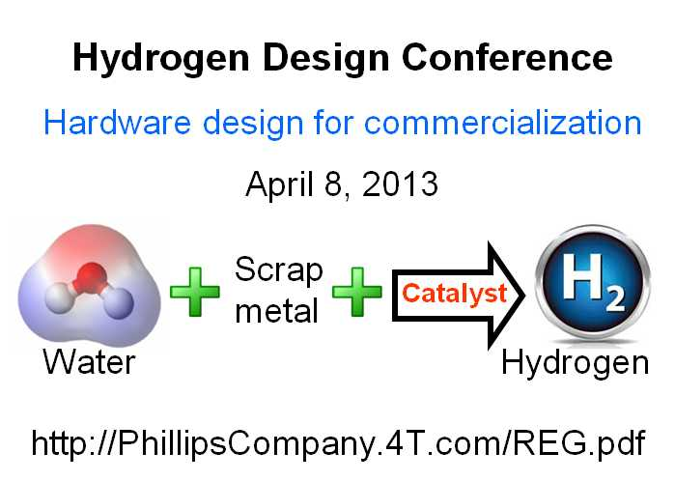

(1888PressRelease) Conference for equipment designers, based on world's first demonstration of economical hydrogen production at high flow rates using water and scrap materials.

Houston, TX - The primary purpose of the conference is to provide information needed by hardware designers and R&D product development professionals who want to learn about new economical methods being used to generate hydrogen at commercially-useful rates. Technical, business, and energy sector specialists will learn hardware design using the world's first scalable Hydrogen-On-Demand process requiring minimum power.
The world's first 30 gallon-per-minute process using catalysts for producing hydrogen-for-fuel was recently demonstrated by Phillips Company. This demonstrated breakthrough in hydrogen production is the basis for the first Hydrogen Design Conference to focus on Hydrogen-for-fuel CC-HOD equipment design. The conference will be held Monday, April 8, 2013, in Millerton, Oklahoma. Registration information is online at www.PhillipsCompany.4T.com/REG.pdf
An important characteristic of this new breakthrough is that it requires no external power input after the hydrogen-producing reaction is started, making possible, for the first time, the scale-up to high rates of hydrogen on demand (HOD) using water and scrap materials for fuel.
A growing number of equipment manufacturers are planning the commercialization of this new method for producing hydrogen fuel at high flow rates by extracting hydrogen from water, using scrap paper and scrap aluminum, two of the world's safest and lowest-cost industrial materials.
Research resulted in the discovery that scrap metals and scrap paper, when burned, can be subjected to an inexpensive catalytic activation process. Then, this mixture can effectively generate hydrogen gas from water. The process uses more water than scrap materials, and the scrap materials do not have to be pure, making the fuel less expensive. The hydrogen production can operate in pH-neutral water, even if it is dirty, and can operate in sea water, the most abundant source of hydrogen on earth.
This simple, straight-forward hydrogen-generation approach appears to be the only method, worldwide, that (1) results in more energy when the hydrogen is used (combusted, burned) than the energy required to generate the hydrogen; and (2) uses only low-cost and friendly materials (carbon and fuel); and (3) uses only two fuels (scrap aluminum and water); and (4) can generate ANY rate (LPM, GPM) of hydrogen, limited only by the hardware design; and (5) because of the above, eliminates the need for hydrogen storage tanks for most applications; and can (6) generate hydrogen, directly from the cell, at ANY pressure, limited only by the hardware design; and (7) can produce the hydrogen on demand, or "HOD;" and (8) produces only TWO products (hydrogen and aluminum hydroxide, AH); and (9) after harvesting the hydrogen, the AH by-product is environmentally safe and can be either discarded or recycled; and (10) can produce hydrogen with no critical parameter control, leading to a hydrogen manufacturing process that is said, by manufacturing engineers, to have a wide process latitude, which leads to easy control and therefore low cost for hardware used to produce the hydrogen.
The unique thing: This is the world's first method that can produce more energy from the burning or combustion of hydrogen than the small amount of energy required to generate the hydrogen.
The Hydrogen Design Conference is responding to companies that can produce hardware and commercialize the technology in the form of fuel for vehicles, hydrogen fuel for electric power generation, hydrogen fuel for heating, and hydrogen fuel for water distillation. "We think using hydrogen to fuel ships is promising because the process works well for producing hydrogen from sea water. More importantly, we think it makes sense to use hydrogen to fuel electric power generators on islands or in remote locations where water is plentiful and cheap, compared to the cost of importing diesel via tanker ships." Hydrogen can be used either as a primary fuel, or as a boost fuel. Boost applications offer the advantage of lowering the fuel costs with no modifications or retuning of gasoline and diesel engines.
The Hydrogen Design Conference will be held in Millerton, Oklahoma USA on April 8, 2013. Contact Phillips Company, hp ( @ ) valliant dot net, to register attendees dot European attendees can register by contacting Bion Technology in England, fred dot davey ( @ ) biongroup dot co dot uk dot
http://www.PhillipsCompany.4T.com

###

