October 20-26 is Radon Action Week in U.S.A. | Take Action Against America's Leading Household Killer! SWAT Environmental is Saving Lives

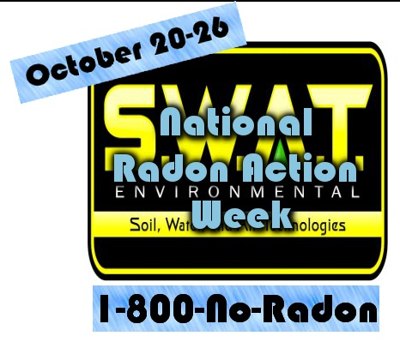

1888 Press Release - Radon action week is one week dedicated to informing people about the dangers of radon gas. The EPA released a graph informing readers that radon gas causes more deaths than car crashes per year. Because radon gas is so dangerous and a huge mystery, radon action week was created.

Indianapolis, IN - Radon Action Week
Radon Action Week is October 20 thru 26 and radon gas experts are urging renters and homeowners to make sure that they have the home checked for dangerous radon gas. The coordinators for Radon Action Week are trying to make the public aware how dangerous this radioactive gas can be if left unchecked. The gas is odorless, colorless and tasteless, which presents a problem for homeowners who feel because they cannot detect it like natural gas, that there simply is no trouble. The Radon Action Week experts will explain how natural gas has a smell added to it to allow homeowners to detect leaks. No such smell is added to radon gas.
Radon Action Week will help you to better understand how at low levels the radon gas may be harmless, but if left undetected, the levels can rise to a very dangerous level. This becomes an immediate danger to your family when the radon gas is allowed to seep into your home. The experts at the Radon Action Week will tell you that as the concentrated levels rise in your home, everyone is in danger. You will then have to have a certified radon technician set up piping and a ventilation system to disperse the gas safely out of your home. You can attend your local Radon Action Week and pick up more information, as well as details where to get your very own radon testing lit so you can ensure the property is safe.
The Radon Action Week says that the EPA claims radon is one of the most serious health risks to the public, and has been proven to be the second biggest cause of lung cancer in the US. Radon Action Week will help you to better understand the immediate dangers and how you can be proactive in the location and release of this radioactive gas. Radon Action Week says that you do not want to be one of the 21,000 cases of lung cancer that are a direct result of exposure to the radon gas.
At the Radon Action Week you will see that the EPA set the action level at 4 picocuries for each liter of air. That being said, even significantly lower levels of radon gas might be harmful to the elderly, children and adults with certain respiratory conditions. Radon Action Week can help you to better understand what efforts you need to be making as a homeowner to prevent a situation from escalating. The EPA also says one of every fifteen homes in the US have radon gas in their homes in an elevated level. Radon Action Week is to help make you aware of the radon gas, how frequent it is in your area, and how to protect your home and family.
At the Radon Action Week you will have the ability to pick up specific information concerning radon gas that is directly related to your individual state. You will also receive information at the Radon Action Week of where you can pick up a radon test kit near your home.
The Radon Action Week will show individuals why the radon gas is so successful at killing thousands of people each and every year. Because it is undetectable using your senses, the Radon Action Week will show you inexpensive and simple ways that you need to protect your family. There really is no excuse for not taking a proactive stand, so find time to attend Radon Action Week.
http://www.MitigationSystem.com

###

