Jimmie Lee, The Jersey Outlaw Explodes Into The Poker World
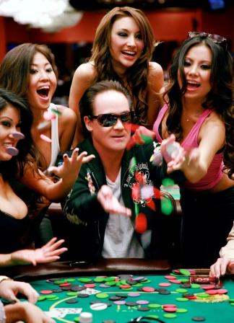

(1888PressRelease) Poker-Rocker Jimmie Lee-The Jersey Outlaw raises up the stakes with his two new hit singles for poker, IM ALL IN and HIT THE RIVER RUNNING that have garnered worldwide attention!

Las Vegas, NV-AZ (1888PressRelease)The bad boy of country rock, Jimmie Lee has exploded into the poker world this year, armed with his two hit singles for poker, IM ALL IN and HIT THE RIVER RUNNING. On the heels of his most recent CD release, KID VEGAS, Jimmie is currently touring with venues throughout the USA and making big appearances at celebrity and charity poker tournaments now! And The Jersey Outlaw has just raised up the stakes , with the big photo shoot with The Prestigious Models from NYC, at Trump Taj Mahal Casino in Atlantic City!! This big promo event's the catalyst for Jimmies big road tour and upcoming poker events. And now we all know about Jimmies latest exploits and who's in the limo, (psst- it's the bandito girls, Jen, Whitney, and Jasmine!)
Poker-Rocker Jimmie Lee has made a big splash in poker this year with his two hit songs, both cowritten by hotaussiechick and poker pro, Danielle Adams-Benham, and he continues to make his mark on the poker world! Both poker songs have received critical acclaim and have garnered major airplay with several poker radio stations, as well as rave reviews in poker magazines that include Card Player, Ante Up, Poker Pro, Poker Shark and more! Jimmies the "talk of the town" in poker, and will be featured at several celebrity and charity poker events early 2012. This is coupled with Jimmies upcoming road tour 2012, that will include stops to Vegas, San Antonio, Dallas, Los Angeles, Chicago, Nashville, Memphis, New York, Atlantic City, Philadelphia and more! The Outlaws got a sizzling brand new show with his new songs from the new CD, KID VEGAS, along with the classic Jimmie Lee hits from previous albums.
Jimmie Lee continues his quest into superstar status as a consummate entertainer and performer! He's already released several CDs worthy of catchy energetic tunes by Grammy Music producer, David Ivory. Jimmies hits include Lets Go, Kickin Ass, Country Rocker, Forever 29, Gimme A Holler, Cross Country 4 Wheel Drive, Kid Vegas , Gone , and many other hot songs. So be sure to purchase Jimmies music at CD Baby, iTunes and Select Stores!
Jimmies music and all appearances can be found at www.jimmieleesongs.com
And be sure to check out Jimmies new music video for his newest smash poker song, HIT THE RIVER RUNNING on YouTube:
http://youtu.be/6LdBI2aDNRU.
You can rest assured that The Jersey Outlaw plans on raisin' up the stakes , and pushin his chips all in for 2012, on his 2 new hit singles for poker ! NO BLUFF!

Trackback URL:

http://www.1888pressrelease.com/jimmie-lee-the-jersey-outlaw-explodes-into-the-poker-world-pr-363557.html

###

