Swingers Cruise Setting sail Belize 2011
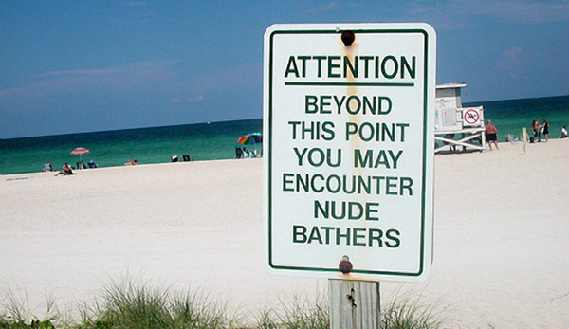

(1888PressRelease) April 25th 2011 is expected to be the largest swingers cruise, with 5 decks already sold out in a matter of days.
(1888PressRelease) - The most heralded and talked about event for swingers cruise's is expected to sell out the 2500 capacity in not time. Launching a short while back with bookings, five of the 13 decks have been booked almost immediately. The cruise leaving form Belize is not the only Swingers cruise for the year, there are two other trips filling up at a rapid pace just as quickly as Belize.
In August of 2011 another trip is already filling up launching out of Alaska, and some cruises in 2012. The Belize trip will enjoy exotic locations from Playa del Carmen, to Belize. The Alaska trip leaves the beautiful shores of the Pacific Northwest in Vancouver BC, with stops in Straight Point, Hubbard glacier and more.
There's still time to make your reservations for the biggest swinger cruise of 2011 and 2012. From the warm waters of Mexico, to the captivating views of Alaska, to the exotic outreach of the Galapagos Islands, these cruises will stimulate your mind and body.
Please visit http://www.swinglifestyle.com/swingers_cruise/.
Trackback URL:
http://www.1888pressrelease.com/swingers/cruise/swingers-cruise-setting-sail-belize-2011-pr-249335.html
###

