Brooklyn Mold Removal Company Helping With Hurricane Sandy Toxic Mold Infestations
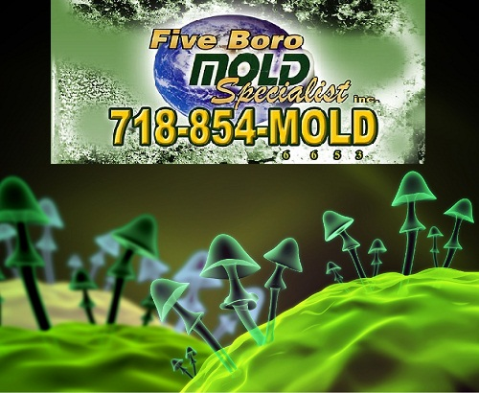

(1888PressRelease) Brooklyn Mold Removal Company, Five Boro Mold Specialist, Has Recently Been Recognized for Helping With Hurricane Sandy Relief Efforts.

New York, NY - Brooklyn Mold Removal Company, Five Boro Mold Specialist, Helping With Hurricane Sandy Relief.
New York City Mold inspection company announced today that their completely revamped mold detection and elimination procedures and services. They have recently received attention for the Hurricane Sandy relief efforts and services. Being certified, insured and registered with FEMA and OSHA for NYC mold inspection and mold removal, Five Boro Mold Specialist and owner Motty Katz, have both been featured in trade journals in New York City, been on local NY TV stations, have write ups and articles in many NYC newspapers including the Nytimes, and have recently been awarded AngiesList.com Super Award for professional NYC mold inspection and mold removal services.
A spokesperson for NY Mold Removal stated- "Our newly updated reporting system has received tremendous support from insurance companies that specialize in flood damage and mold insurance policies. The certified expertise of our mold remediation experts enables them to discuss changes with the home or business owner that would prevent future mold infestations. This may involve something as simple as installing a sump pump or dehumidifiers in basement-like situations, though dealing with the mess from Hurricane Sandy, literally everyone is at risk with the amount of hazardous waste, toxic contaminants and bacteria issues from raw sewage, and toxic mold from the flooding".
The NYC mold removal company considers educating the public about the effects of mold as a priority and their website exemplifies this with numerous articles that go into detail about the effects of mold.
The moment an order is received, they send two mold experts to your location. The mold experts will not only examine the main affected location but will take measurements from various neighboring places. Even though you may not see mold, you might still have a mold infestation problem. The next step would be to identify areas of large concentration of the mold spores. Mold concentrations provide a unique thermal signature. These thermal signatures can be typically detected using thermal imaging. The most straight-forward device that can be used for thermal imaging is an infrared camera. Thermal imaging using infrared technology should be the de facto method for detecting mold, as even large concentrations of mold may not be visible to the naked eye. Just like humans, houses have their own baseline temperature. So it is important to take temperature measurement from various parts of the house, so that the thermal imagery can be calibrated for accurate mold detection.
Brooklyn Mold Company has a reputation of providing top of the line service when it comes to mold detection and elimination. Over the past decade their satisfaction rating has gone from 90% to a remarkable 97%. Their motto of 'Excellent Service - Fast' is more than lip service, talk to any of the 97% of satisfied customers to see that.
With the commitment of NY Mold Removal to New York City tri-state area business and homeowners, the company is leaving no stone unturned in making the experience of mold remediation as pleasant as possible for the home or business owner under the current circumstances. For further information about Brooklyn mold inspections, Brooklyn mold removal, or Brooklyn mold remediation, contact-
www.moldinspectionsbrooklyn.com
http://www.FiveBoroMoldSpecialist.com

###

