Muskoka Recovery Center- A Place to Get Rid Of Addictions
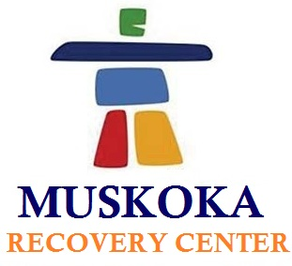

(1888PressRelease) Muskoka Recovery Center implements numerous effective therapies to help patients get rid of addiction problem. Professionals holding expertise in their field offer you services to show you the path towards a new sun rise.

(1888PressRelease) Muskoka Recovery Center serves the Canadian people with proficient handling of various types of addiction counseling besides providing treatments to their patients. We indulge team of well qualified professionals, holding expertise in their specified areas. Here at Muskoka Recovery Center, patients suffering from drug or alcohol addiction are given proper treatment along with effective one-o-one counseling sessions. Besides, families which are facing difficulties in controlling their drug or alcohol use are provided with special counseling. Muskoka Recovery Center is renowned as the best Rehab center in Toronto, specializes in providing several treatment programs depending upon the condition of every individual.
The main concern of us is to provide routinely and personalized counseling services as to attain remarkable improvement in the lives of numerous adolescents, young adults, adults and families as well. We at Muskoka Recovery Center indulge professionally qualified people taking recovery to the height of success. We provide our patients with elite facility and all the comforts so that he/she can recover faster along with building a confidence level. The alcoholism Rehabilitation Center of Canada is renowned across the globe due to its world class facilities and experienced doctors. Some of the appreciable facts include:
• It is known as one of the well known recovery centers of the country having the highest success rate.
• It is the only Rehab offering guaranteed success result.
• Other then Muskoka Recovery Center no other rehab center offers recovery treatments for Methadone addiction.
In the year 2005, the Founder & Executive Director of Pickerel Lake Recovery Center, John began to build up a model and design for an inimitable treatment Center. And after 3 years continuous day and night hard work and through research, the existence of Muskoka Recovery Center came as a truth. Over a serene area of 140 acres Muskoka Recovery Center is located in North Muskoka. To provide comfort zone and relaxing environment Muskoka Recovery Center has indulges world class amenities of resorts providing the best treatments for every type of addictions.
It is a recovery center indulging high class facilities as to make the patients feel at home and avail them every type of facility that they wish for such as gym, lounge, indoor pool and fishing and so on. We believe that recovery is faster if the patients comfort zone is proper. So our main motive is to get the patients the best facilities as to attain higher recovery rate. We provide various types of treatments such as massage therapy, Reiki and numerous other effective services, which help to recover soon besides, also lead you to a successful life.
To avail more information or for any query you can contact us through email at info ( @ ) muskokarecovery dot com Or can also call us at 1-877-966-6887
Visit http://www.muskokarecovery.com for getting more details and information on different counselling sessions.

Trackback URL:
http://www.1888pressrelease.com/muskoka-recovery-center-a-place-to-get-rid-of-addictions-pr-410696.html

###

