Greenbrideguide.com Announces 10 Stop Eco-wedding Tour At National Bridal Shows
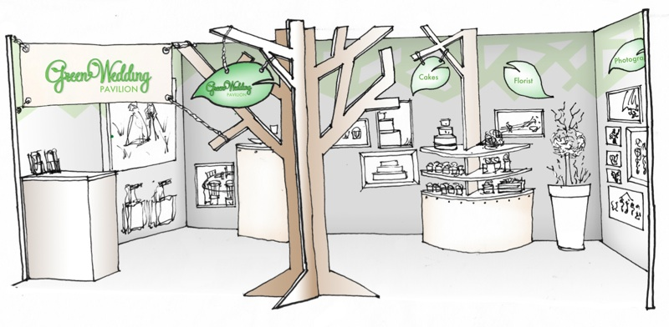

(1888PressRelease)Traveling Exhibit Is Made Of All Sustainable Materials And Shows Couples How to Go Green.

Hartford, CT (1888PressRelease) The nation's leading green wedding site is taking to the road in 2012, opening its ten-city tour on January 7 in Phoenix, Arizona. Its exhibit will include some of the nations leading green wedding providers in an effort to showcase the growing green wedding movement, as well as GBG's take on a sustainable bridal show booth.
"The booth itself is 100% 'green'," says environmental lawyer Kate Harrison, who started GreenBrideGuide.com in 2009 after her book The Green Bride Guide: How To Plan An Earth-Friendly Wedding On Any Budget became a best seller in the wedding category (Sourcebooks, 2008).
The 10x20 booth features six eight-foot tall recycled cardboard trees, connected with bamboo poles and linen curtains. The shelves are all constructed from the same material, and the entire booth packs into an 8' x 4' x 18" box. Each vendor featured at the shows is marked with a reclaimed wood frame. A description of what makes each product green is displayed on a reusable chalkboard garden sign in a small terracotta pot with real moss, and the sign marking the entrance to the pavilion is printed on recycled tyvek.
"Our green pavilion is the first of its kind," continues Harrison, "a green experience through and through. We wanted to make a strong statement about what it means to do sustainable business on this tour, and it starts with the booth."
Two years of extensive research by the staff of GBG has led to an impressive catalog of 1,300+ green businesses who serve weddings and other gift needs, and to put it to work, they developed the GBG Gift Registry which is demonstrated at the booth. The Registry showcases eco-friendly home goods including recycled metal pans with non-toxic coating, plush organic bath towels and sustainably harvested mango wood bowls to name just a few examples.
The booth also features a number of Green Bride Guide's partners including: Mywedding.com (wedding websites), Mango Ink (invitations), Twisted Limb Paperworks (invitations), Cast Paper Arts (invitations and favors), Favor Creative (favors), One World Flowers (flowers), Blumebox (floral containers), and Mexico (honeymoons).
For details on the tour and the participating companies, visit to www.greenbrideguide.com/eco-wedding-tour
The show schedule appears below:
Bridal Fashion Debut Phoenix, AZ 1/7/12-1/8/12
Seattle Wedding Expo Seattle WA 1/14/12-1/15/12
Elite Events Atlanta GA 1/22/12
Dallas Bridal Show Dallas TX 1/28/12
Baltimore Bridal Show Baltimore MD 2/4/12
Great Bridal Expo New York NY 2/10/12
Elite Events Savannah GA 2/26/12
Houston Wedding Showcase Houston TX 3/03/12
Washington Bridal Showcase Chantilly VA 4/15/12
Rocky Mountain Denver CO 4/22/11
The Green Bride Guide is the comprehensive and credible resource for green wedding product and services. The site's directory connects couples with green wedding service providers in their area, such as restaurants that serve local, organic food and limousine companies that use hybrid vehicles. The directory includes vendors throughout the United States, Canada and the United Kingdom. For further information on the Green Bride Guide go to www.greenbrideguide.com.
http://www.greenbrideguide.com/eco-wedding-tour

Trackback URL:
http://www.1888pressrelease.com/greenbrideguide-com-announces-10-stop-eco-wedding-tour-at-na-pr-365102.html

###

