Hydrogen production breakthrough

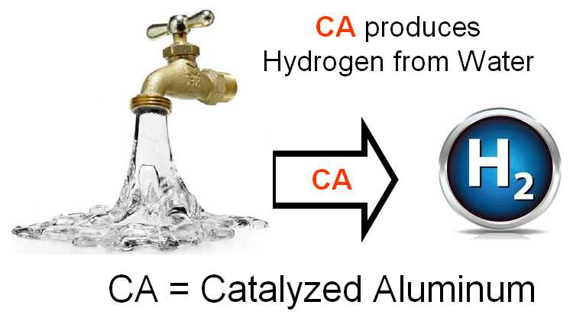

(1888PressRelease) World's first demonstration of hydrogen production at high flow rates using scrap materials sparks Hydrogen Design Conference for commercial equipment design.

New York, NY - The world's first 30 gallon-per-minute process using catalysts for producing hydrogen-for-fuel was recently demonstrated by Phillips Company. This demonstrated breakthrough in hydrogen production is the basis for the first Hydrogen Design Conference to focus on Hydrogen-for-fuel CC-HOD equipment design. The conference will be held Monday, April 8, 2013, in Millerton, Oklahoma.
The primary purpose of the conference is to have a meeting where hardware designers and R&D product development professionals can learn about new CC-HOD methods being used to generate hydrogen at commercially-useful rates. Political, business, academia, energy sector specialists and professionals will analyze hardware design and chemistry using the world's first scalable Hydrogen-On-Demand process requiring minimum power input.
An important characteristic of this new breakthrough is that it requires no external power input after the hydrogen-producing reaction is started, making possible, for the first time, the scale-up to high rates of hydrogen on demand (HOD) using water and scrap materials for fuel.
A growing number of equipment manufacturers are planning the commercialization of this new method for producing hydrogen fuel at high flow rates by extracting hydrogen from water, using scrap paper and scrap aluminum, two of the world's safest and lowest-cost industrial materials.
Research resulted in the discovery that scrap aluminum and scrap paper, when burned, can be subjected to an inexpensive catalytic activation process. Then, this mixture can effectively generate hydrogen gas from water. The process uses more water than scrap materials, and the scrap materials do not have to be pure, making the fuel less expensive. The hydrogen production can operate in pH-neutral water, even if it is dirty, and can operate in sea water, the most abundant source of hydrogen on earth.
This simple, straight-forward hydrogen-generation approach appears to be the only method, worldwide, that (1) results in more energy when the hydrogen is used (combusted, burned) than the energy required to generate the hydrogen; and (2) uses only low-cost and friendly materials (carbon and fuel); and (3) uses only two fuels (aluminum and water); and (4) can generate ANY rate (LPM, GPM) of hydrogen, limited only by the hardware design; and (5) because of the above, eliminates the need for hydrogen storage tanks for most applications; and can (6) generate hydrogen, directly from the cell, at ANY pressure, limited only by the hardware design; and (7) can produce the hydrogen on demand, or "HOD;" and (8) produces only TWO products (hydrogen and aluminum hydroxide, AH); and (9) after harvesting the hydrogen, the AH by-product is environmentally safe and can be either discarded or recycled; and (10) can produce hydrogen with no critical parameter control, leading to a hydrogen manufacturing process that is said, by manufacturing engineers, to have a wide process latitude, which leads to easy control and therefore low cost for hardware used to produce the hydrogen.
Experts agree that hydrogen will command a key role in future renewable energy. For years, the world's clean-energy goal has been to have a relatively cheap, safe, efficient and non-polluting means of producing hydrogen on demand, at very high rates which make hydrogen storage tanks unnecessary. That goal has been met, for the first time, with a new process using safe, low-cost materials.
The unique thing: This is the world's first method that can produce more energy from the burning or combustion of hydrogen than the small amount of energy required to generate the hydrogen.
Hydrogen is an energy dense and clean fuel, which upon combustion releases only water vapor. Today, most hydrogen is produced from thermoforming and electrolysis. Those methods require large amounts of electrical energy and/or result in excessive carbon-dioxide emissions. An alternative, clean method is to make hydrogen from water. The new process is called CC-HOD, or Catalytic Carbon, Hydrogen on Demand.
Before this new process was developed, the use of hydrogen fuel was limited by the lack of a cheap catalyst that can speed up the generation of hydrogen from water. The new catalytic process is based on chemistry theory that is developed and ready for commercialization. "We are in discussion with potential licensees. Business agreements with additional licensees, particularly manufacturing companies, are planned," said the licensing agent for Phillips Company.
Phillips Company is searching for companies that can produce hardware and commercialize the technology in the form of fuel for vehicles, hydrogen fuel for electric power generation, hydrogen fuel for heating, and hydrogen fuel for water distillation. "We think using hydrogen to fuel ships is promising because the process works well for producing hydrogen from sea water. More importantly, we think it makes sense to use hydrogen to fuel electric power generators on islands or in remote locations where water is plentiful and cheap, compared to the cost of importing diesel via tanker ships."
These applications are now possible because this process is the world's first method that can be scaled up to produce hydrogen on demand at very high flow rates using catalytic carbon to limit the input energy to only a small amount. Because the hydrogen-producing process uses pH-neutral chemistry, the hardware corrosion problems are virtually nil.
Introduction of this new technology will first be used as a fuel supplement to increase the efficiency and reduce the cost of existing petroleum fuels. This is called "boost" operation because MPG can be increased with only a small amount of added hydrogen. This can be done without any modification to existing engines apart from introducing the hydrogen into the air intake manifold of the engine. Oxygen sensor operation requires no modification when pure hydrogen is used as a fuel supplement. "This has been demonstrated by using hydrogen as a fuel additive in conventional automobiles to increase the mileage (miles per gallon) by more than 30% with no modification to the engine," said a company spokesman.
The Hydrogen Design Conference will be held in Millerton, Oklahoma USA on April 8, 2013. Contact Phillips Company, hp ( @ ) valliant dot net, to register attendees who wish to attend the conference dot French-speaking attendees can contact our Canadian Authorized Agent, Mr dot Richard Lepine, ALplusH2O ( @ ) neew dot ca dot European attendees can register by contacting our Authorized Agent, Mr dot F dot Davey, Bion Technology in England, fred dot davey ( @ ) biongroup dot co dot uk dot Contact any of the above for technical information, agenda details and travel recommendations dot
Catalyzed Aluminum (CA) and Catalytic Carbon (CC), the world's lowest-cost and best catalysts for producing hydrogen from water are described online at www.PhillipsCompany.4T.com/REG.pdf
http://www.PhillipsCompany.4T.com/HYDROGEN.html

###

