Joseph Macchiarulo announces his soon to be released book: "100% Travel and Loving It! A Road-Warrior's Survival Guide"
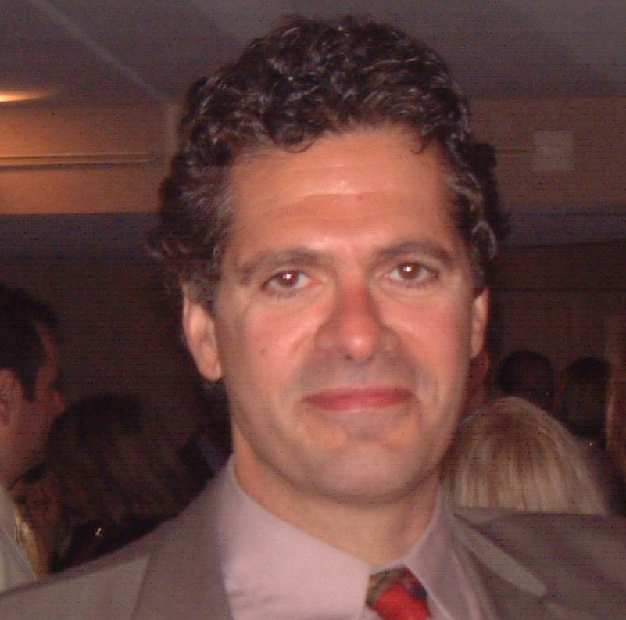

(1888PressRelease) Joseph Macchiarulo will soon release a book outlining the creative strategies he's developed in over 20 years of extensive travel as a business consultant for optimizing the quality of life and having fun while "on the road".

Joseph Macchiarulo has a 100% travel occupation as a business consultant with one of the "Big 5" consulting firms; and after 20 years of extensive travel he's discovered some creative ways to improve the quality of life while "on the road". In his soon to be released book: "100% Travel and Loving It! A Road-Warrior's Survival Guide: How to Travel, Work Hard, and Have the Time of Your Life!", Mr. Macchiarulo provides an in-depth understanding of key strategies for making the most out of work-related travel that he has discovered through years of trial, tribulation, and fun while on the road.
Here are some highlights of some of the things Mr. Macchiarulo has discovered along the way which he describes in greater depth in his soon to be released book:
DEFINING YOUR GOALS
Mr. Macchiarulo formulated his strategy and approach in an informal way, not even realizing he had developed a strategy until he reflected back on how the whole thing happened. The first thing Joseph did when he started traveling extensively was ask: "What do I want out of this lifestyle?" The answer to that question resulted in six key goals:
• Minimize travel time
• Optimize free time
• Maintain a healthy work-life balance
• Stay in shape
• Maximize travel benefits
• Have fun!
DEVELOPING A STRATEGY
Again, without realizing it, Joseph Macchiarulo developed an "overarching strategy" to achieve his six goals:
• Travel light
• Create a home away from home
• Explore the opportunities of travel
• Leverage technology
Now we get to what Joseph Macchiarulo actually did to implement his strategy and achieve his goals:
TRAVEL LIGHT
Travel starts with packing and ends with unpacking. Joseph learned to narrow down his travel items to the things he actually needed for work, exercise, and leisure while on the road. Mr. Macchiarulo soon realized that four shirts and two pair of work pants would provide enough variety on the job. For exercise he could get by on one pair of sneakers, workout shorts, and a t-shirt. And since Joseph's "smart-phone" is a phone, a calculator, a portable library of music, a camera, and an internet browser, he soon realized that the only gadgets he needed for work, leisure, and exercise was his iPhone, a set of "ear buds", and his laptop computer! Well almost: Joseph Macchiarulo is also a professional songwriter, so he also wanted an acoustic guitar with him at all times; and he did not want to be schlepping a guitar back and forth every weekend, which is a good intro to the next strategy …
CREATE A HOME AWAY FROM HOME
The key to this strategy is to stay at the same hotel every week. Hotels are happy to hold items over weekends. So Joseph takes one large suitcase, one guitar, and his backpack the first time he travels to the remote location for his new work assignment. Mr. Macchiarulo leaves the large suitcase and guitar with the hotel concierge each Thursday when he checks out and picks them up on Sunday when he returns. With this approach, Joseph only has to check a bag into baggage claim two times during the many months he spends on every project: the first time he travels to the new location, and the last time he travels home. This allows him to travel back and forth every weekend without going through baggage claim. Joseph also looks for a hotel with a good fitness room as close to his work location as possible (allowing more time in the morning for exercise) and books weekly reservations for the entire length of the project. He purchases "energy shots" to save time in the morning by not having to brew coffee; and he keeps plenty of protein powder on hand for a quick post-workout "breakfast" before he heads to the office exhilarated, focused, and ready for a good day of work. Mr. Macchiarulo often purchases a multi-speed bicycle in his work location to get around town in the evenings and on Sundays (while listening to music on his iPhone). When the project is over, Joseph either sells the bike, sends it home, or leaves it with a local friend if he expects to return to that city at some point in the future. And with an acoustic guitar at his hotel, Joe can play and write music in the morning or in the evenings after a long day in the office before he heads out for a nice meal and a glass (or more) of wine at one of his favorite restaurants, which is a good lead-in to the next strategy …
EXPLORE THE OPPORTUNITIES OF TRAVEL
By booking most of his trips using one or two major airlines Mr. Macchiarulo maximizes his points and achieves a higher "status" more quickly. Joseph's priorities for airlines are: safety, reliability, customer service, and a good frequent flyer program. Mr. Macchiarulo's favorite airline thus far is Jet Blue because they never sub-contract any flights, they constantly upgrade their fleet, have a good track record for being on time, have short call center hold times with knowledgeable representatives, and have a user-friendly website making it easy to book and manage flights. Jet Blue's frequent flyer program has no "black-out dates" and points that do not expire; and they even provide cash bonuses to your Jet Blue account (in addition to frequent flyer miles) when flights are delayed.
On the hotel front, Mr. Macchiarulo tends to stay in Hyatt and Hilton hotels most of the time. By focusing on one or two hotel chains he maximizes his points and achieves a higher "status" more quickly. Major hotel chains like Hyatt and Hilton will match your current status with a competitor. This bump in status has many benefits, like upgraded rooms, free Wi-Fi, free breakfast, and extra points for each stay. When you travel every week, as Mr. Macchiarulo does, you can accumulate hotel points very quickly. So between frequent flyer miles and hotel points, when vacation time rolls around everything is paid for except meals and entertainment, which allows Mr. Macchiarulo more vacation money for having fun!
And when it's time to have fun, Joe doesn't want to have work on his mind. He quickly learned to use every available moment of his travel time between home and his work location to get work done. With today's laptop computers and smart phones, Mr. Macchiarulo gets a great deal accomplished waiting at the airport for his flight (and if it's delayed, the extra work time is an added benefit). Joe also gets things accomplished sitting on the plane en route to his destination. Mr. Macchiarulo soon realized that using his travel time to get work done not only makes the travel time "fly by" more quickly (no pun intended), it also frees up time both at home as well as in the evenings after work when he's away from home to have fun! Joseph's approach to "fun" is quite simple: great restaurants, entertainment, and site-seeing. With applications like Yelp, OpenTable, and TripAdvisor it is "easy as pie" (no pun intended) to find a wide-variety of fine restaurants close to his "current location" (using his iPhone's GPS) along with customer reviews, menus, and even photos of many dishes! Through the same applications he can quickly call a restaurant to see how crowded it is, make a reservation, and get instant directions to the restaurant. Mr. Macchiarulo chooses restaurants with great atmospheres, great food, great service, and last but definitely not least: a good selection of good wines by the glass (one of life's simple pleasures).
On the entertainment and site-seeing fronts, Mr. Macchiarulo tries to get projects in places with a variety of museums, theater, and live music. Joseph has walked the Great Wall in China, been to virtually every museum in Manhattan, Washington D.C., and Philadelphia; and he's seen Broadway plays, great jazz, blues, and folk performances - you name it.
If you have to travel for work, you might as well make the best of it. Read Joe's book when it's released and you'll get more details on how to travel for work and have the time of your life!
https://www.facebook.com/joseph.macchiarulo.5?ref=tn_tnmn

###

