Name of Game | Bloody Monsters - Zombie Shooting Game for Kindle
Email | mary@rvappstudios.com
Publisher | RV AppStudios
Summary Description | Shoot the bloody monsters & survive the carnage, in this extremely fun arcade shooter game with a bouncy twist. Bloody Monsters provides hours of entertainment as you master the art of a shooter in this fun shooting game. The monsters are everywhere and your job is to "Shoot The Bloody Monsters"! You have limited bullets but they bounce all over the place.
Size (MB) | 19.8MB
Version | 1.0
App/Game Category | Games
App/Game URL | http://www.amazon.com/RV-AppStudios-Bloody-Monsters/dp/B00BNB464Q/
Game Logo | 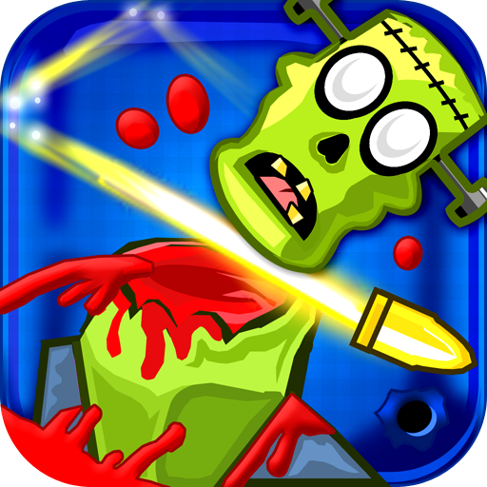
Price | Free
Languages | English
Release Date | 11/03/13
Full Description | Shoot the bloody monsters & survive the carnage, in this extremely fun arcade shooter game with a bouncy twist. Bloody Monsters provides hours of entertainment as you master the art of a shooter in this fun shooting game. The monsters are everywhere and your job is to "Shoot The Bloody Monsters"! You have limited bullets but they bounce all over the place.  Unlike other shooting games your bullet can kill multiple monsters in one shot. The bullets are super powerful and keep killing till they stop bouncing, so try to use as few bullets as possible for a higher score. Simply aim & fire and hope the bullets bounce your way.  Key Features:  - Kill Different Kinds Of Monsters  - Experience The Sensation Of Firing Bullets Wildly  - Multiple Powerful Guns & Weapons  - 240 Levels Of Fun (More Levels Coming Soon)  - Awesome Blood & Gore Animations  - Realistic & Fun Blood Sounds  The game includes multiple different monsters and provides various powers to help kill the monsters. While the bouncy bullet is extremely powerful, at times you'll need to use some of the more powerful guns & weapons. Each gun has specific properties that will help you beat the level. Save your ammunition & special powers till you end when you might need them the most.  Bloody Monsters, is a super addicting strategy shooting game that will keep you entertained for hours. If you love physics game and love blood & gore; and are in the mood for some serious gun shooting fun then this game is for you.  Tip: Be sure to assassinate all the monsters with a clean headshot for bonus points & fun.  Why Play Bloody Monsters?  If you're into sniper games, hitman games, or assassin games, where you are the shooter looking to kill with a sniper gun, then Bloody Monsters is the absolutely best 'take a break game' for hard core gamers. With Bloody Monsters you get to play a shooter game in a more relaxed mode, since one bullet can kill multiple monsters and bounce all over the place! Bloody Monsters is a relaxed fun physics game, yet it still has that awesome blood & gore feeling when shooting those bloody monsters.  Bloody Monsters is an extremely fun shooting game. Download Bloody Monsters Today!  If you like the game then please support us by doing the following:  1) Be Sure To Review The Game  2) Sharing this game with your friends on Facebook & Twitter.  3) Checking out some of our other cool games from RV AppStudios.  PLEASE NOTE: This app lets you purchase digital content using actual money. You can configure parental controls for in-app purchases, which will require your Amazon account password or a 4-digit PIN, by going to the Settings menu from within the Amazon Appstore.
Screen Shots  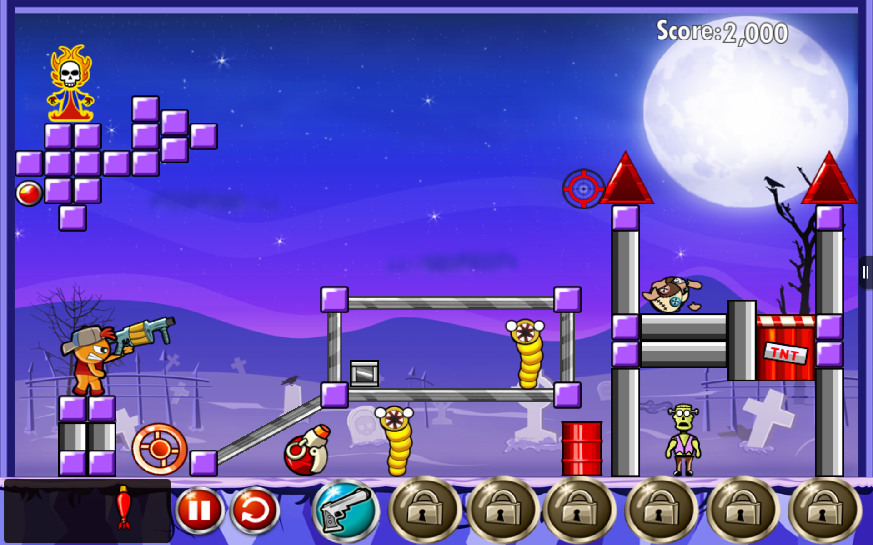 | 