Winning the war on bacteria superbugs: Reversing the trends
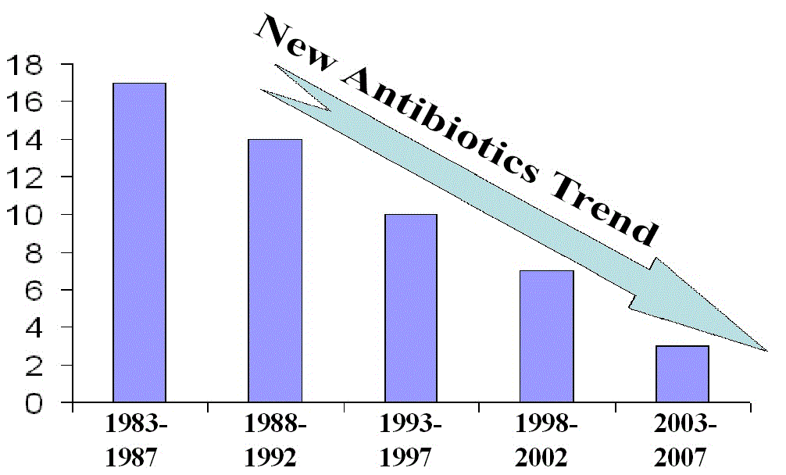
(1888PressRelease) A new topical antibiotic formulation, designed to overcome drug resistance of MRSA, is now available OTC. Known as Tetracycline-ABC, it kills the most drug-resistant and the most deadly bacteria (Staph, MRSA and Acinetobacter), which cause community or hospital acquired infections.
(1888PressRelease) Since the discovery of two classes of antibiotics over 70 years ago, penicillin in 1929 and the first sulfonamide, prontosil, in 1932, the ensuing decades have given rise to a total of 13 classes of antibiotic, some now in their fifth generation. At the peak of development, new drugs were coming out at a rate of 15 to 20 every ten years, but in the last ten years, we have seen only 6 new drugs, according to Medical News Today.
Many pharmaceutical companies are abandoning or scaling back antibiotic research and development in favor of more profitable drugs that treat chronic conditions. However, a novel antibiotic design to overcome drug resistance of antibiotics was announced today by Phillips Company, an FDA-registered Native American owned pharmaceutical manufacturer.
"Our company is a not-for-profit pharmaceutical developer. We are not driven by profits, so we can focus on what is needed more than what is profitable," said a spokesman for Phillips Company. The novel formulation uses both physical and chemical mechanisms of action to kill bacteria. Most existing antibiotics use only a chemical mechanism for effectiveness, resulting in those drugs becoming less effective over time as bacteria evolve to become more able to survive the effects of antibiotics.
The novel approach uses an antibiotic formulation designed to enhance physical transport and physical cell penetration that speeds the active ingredient deep into the cell structure of a wound where the chemical mechanism of action can be more effective.
Methicillin Resistant Staphylococcus Aureus (MRSA), the most notorious antibiotic-resistant strain of staph bacteria, has been wreaking havoc throughout communities all over the world. The CDC announced that there are more people dying of MRSA in the U.S. than of AIDS, raising it to epidemic proportions. To make matters even worse, some experts are now predicting that there will be an emergence of new strains of antibiotic-resistant bacteria in the future.
"Our novel approach to overcome drug resistance of antibiotics is designed to sustain the effectiveness of antibiotics and other topical drugs for many years, giving new topical drug products a longer useful lifetime and therefore more commercial value," said a spokesman for Phillips Company. "This technology, when licensed to larger pharmaceutical companies, will provide stronger incentive for the discovery and development of new antimicrobial drugs. In recent years, the dearth of new antibiotics has been largely due to the uncertainty of the commercial life of new drugs which is diminished when bacteria develop an immunity to the effectiveness of that drug."
The manufacturer believes this is the world's strongest broad-spectrum topical antibiotic. It kills the most drug-resistant and the most deadly bacteria (Staph, MRSA and Acinetobacter), which cause community or hospital acquired infections. The new drug was carefully tested on ten of the most harmful kinds of bacteria and it was found to be the most effective against MRSA, the most notorious antibiotic-resistant strain of bacteria. The Tetracycline-ABC topical antibiotic kills all other harmful Gram positive and Gram negative bacteria that have been available for testing.
Tetracycline-ABC will be licensed to a larger company for manufacturing and commercialization. Phillips Company is a small pharmaceutical development company with manufacturing capacity limited to 50,000 units per month. Using the develop-and-license business model, the company licensed six pharmaceutical products in 2010.
Licensing inquiries: http://www.PhillipsCompany.4T.com
Graphs/images (for re-publiction, if desired) are available (not copyrighted, no charge) online at www.PhillipsCompany.4T.com/NAT.pdf
Trackback URL:
http://www.1888pressrelease.com/winning-the-war-on-bacteria-superbugs-reversing-the-trends-pr-270081.html
###

