SWAT Environmental Provides Free Radon Mitigation Systems to Low Income Families as Radon Awareness Week in America Ends October 21, 2012

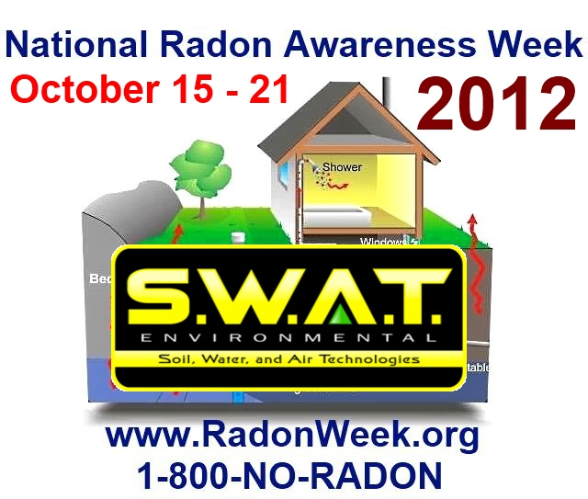

(1888PressRelease) The week of October 15 - 21, 2012 has been designated as National Radon Action Week in the United States. Major government and health organizations, including S.W.A.T. Environmental (North America's largest radon mitigation franchise) have joined forces to put an end to this deadly household terrorist. Free radon testing and radon mitigation services have been offered to some low-income families.

Philadelphia, PA-NJ - Major U.S. Health Agencies have teamed up to fight lung cancer by declaring the week of Oct. 15-21, as "National Radon Awareness Week." This declaration was a huge milestone toward curing America's single greatest in-home health threat, a year after the deployment of EPA's Federal Radon Action Plan.
Radon awareness week will alert the public to the fact that radon is a gas that does not have an odor, taste or color. Radon forms when uranium in the soil, in rocks and in water naturally breaks down and gets into the air that we breathe. Radon awareness week will reveal to the public how the radioactive gas can get into their homes, in schools, in workplaces and any other type of buildings.
During radon awareness week, members of the public will discover how radon moves up from the ground, into the air, and then through cracks found in a building's foundation. Radon awareness week will focus primarily on the gas getting inside of homes. Radon can get trapped inside of a house regardless of whether the house has a basement, is old or new or is drafty or well-sealed.
Radon is not life-threatening when it is on the outside because it is reduced to low concentration levels. However, continued exposure to radon inside of a building can be life-threatening. The dangers of radon inside of a home will be one of the topics discussed during radon awareness week.
The U.S. Environmental Protection Agency (EPA), a primary sponsor of radon awareness week, claims that radon is the second leading cause of lung cancer in the United States. During radon awareness week, the EPA will reveal statistics that show approximately 30,000 cases of lung cancer are attributed to radon exposure. Figures from an EPA report that may be featured during radon awareness week show that 21,000 deaths from lung cancer are caused each year by radon exposure. Smoking is the first cause of lung cancer deaths.
As part of radon awareness week, homeowners will be shown how to test their house to see whether the radioactive gas is in their home. Schools are also encouraged to test for the radioactive gas during radon awareness week.
The U.S. Surgeon General and the EPA advises property owners who are performing these tests during radon awareness week to start testing below the third floor of their house or buildings.
As part of radon awareness week, workers from state, federal and local government agencies will explain how to test for radon in homes. Testing is one of the most popular activities promoted during radon awareness week since the EPA estimates that nearly 1 out of 15 homes in the U.S. have high levels of radon.
There are several inexpensive testing kits that homeowners can purchase from hardware stores or order through the mail during radon awareness week. Testing for radon does not take a long time to do. Property owners can also contact private companies during radon awareness week and set up appointments to have the company conduct the in-home test. Property owners, who cannot find do-it-yourself kits or locate private companies in their areas, can contact their local health department during radon awareness week for this information.
To find out about radon awareness week activities in your area, contact your county health department. To learn more about National Radon Action Week, visit www.RadonWeek.org or call your local health department.
The Open News Association would like to give special thanks to S.W.A.T. Radon Mitigation and their parent company SWAT Environmental Franchises for their assistance.
http://RadonSystem.com

###

