Addiction Canada Treatment Network Announces Their Definition Of "Treatment" From Substance Abuse Disorders And Concurrent Disorders
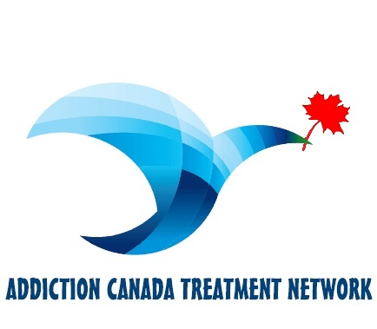

(1888PressRelease) Addiction Canada Treatment Network's definition of treatment for substance abuse disorders and concurrent disorders is being announced by the Network's executive team.

The definitions are the product of a year-long effort by the network team and a wide range of partners in the behavioural health care community and other addiction fields to develop a working definition of treatment that captures the essential, common experiences of those recovering from substance abuse and concurrent disorders, along with major guiding principles that support the recovery definition. The ACTN led this effort as part of its Treatment Support Network.
Addiction Canada Treatment Network's definition of Treatment for Substance Abuse and Concurrent Disorders is as follows:
A process of change through which individuals improve their health and wellness, live a self-directed life, and strive to reach their full potential.
"Over the years it has become increasingly apparent that a practical, comprehensive working definition of treatment would enable policy makers, providers, and others to better design, deliver, and measure integrated and holistic services to those in need," said network Exec Derek. "By working with all elements of the behavioural health community and others to develop this definition, I believe our team has achieved a significant milestone in promoting greater public awareness and appreciation for the importance of treatment, and Canada Wide support for the services that can make it a reality for millions of Canadians."
A major step in addressing this need occurred in August 2010 when the Addiction Canada Treatment Network hosted a series of meetings of behavioural health professionals, consisting of mental health workers and individuals in addiction treatment. Together these people developed a draft definition and principles of treatment to reflect common elements of the recovery experience for those with substance abuse and concurrent disorders.
In the months that have followed, the Addiction Canada Treatment Network team has worked with the Addiction Treatment community and other interested parties in reviewing drafts of their working treatment definition and principles at meetings, conferences, and other venues. In August 2011, the Addiction Canada Treatment Network posted the working definition and principles that resulted from this process on their blog and invited comments from the public via Addiction Feedback Forums. The blog post received many comments, and the forums had over 1000 participants, nearly 500 ideas, and over 1,200 comments on the ideas. Many of the comments received have been incorporated into the current working definition and principles that were incorporated into the Addiction Canada Treatment Network program.
Through their treatment program, the Addiction Canada Treatment Network has also come up with four major dimensions that support a life in recovery:
-- Health: overcoming or managing one's disease(s) as well as living in a physically and emotionally healthy way; -- Home: a stable and safe place to live;
-- Purpose: meaningful daily activities, such as a job, school, volunteerism, family caretaking, or creative endeavours, and the independence, income and resources to participate in society; and
-- Community: relationships and social networks that provide support, friendship, love, and hope.
Addiction Canada Treatment Network Guiding Principles of Addiction Treatment
Addiction Treatment emerges from hope: The belief that treatment is real provides the essential and motivating message of a better future that people can and do overcome the internal and external challenges, barriers, and obstacles that confront them.
Addiction Treatment is person-driven: Self-determination and self-direction are the foundations for treatment as individuals define their own life goals and design their unique path(s) but learn through a comprehensive program of Addiction Treatment.
Addiction Treatment occurs via many pathways: Individuals are unique with distinct needs, strengths, preferences, goals, culture, and backgrounds, including trauma experiences that affect and determine their pathway(s) to addiction treatment. Abstinence is the safest approach for those with substance use disorders.
Addiction Treatment is holistic: Recovery encompasses an individual's whole life, including mind, body, spirit, and community. The array of services and supports available should be integrated and coordinated.
Addiction Treatment is supported by peers and allies: Mutual support and mutual aid groups, including the sharing of experiential knowledge and skills, as well as social learning, play an invaluable role in the treatment process.
Addiction Treatment is supported through relationship and social networks: An important factor in the treatment process is the presence and involvement of people who believe in the person's ability to recover; who offer hope, support, and encouragement; and who also suggest strategies and resources for change.
Addiction Treatment is culturally-based and influenced: Culture and cultural background in all of its diverse representations, including values, traditions, and beliefs, are keys in determining a person's journey and unique pathway to a full recovery.
Addiction Treatment is supported by addressing trauma: Services and supports should be trauma-informed to foster safety (physical and emotional) and trust, as well as promote choice, empowerment, and collaboration.
Addiction Treatment involves individual, family, and community strengths and responsibility: Individuals, families, and communities have strengths and resources that serve as a foundation for addiction treatment.
Addiction Treatment is based on respect: Community, systems, and societal acceptance and appreciation for people affected by mental health and substance use problems "including protecting their rights and eliminating discrimination" are crucial in achieving overall Addiction treatment and recovery.
http://www.addictioncanada.ca

###

