Cargo Ship Fuel Cost Savings Possible With New Technology

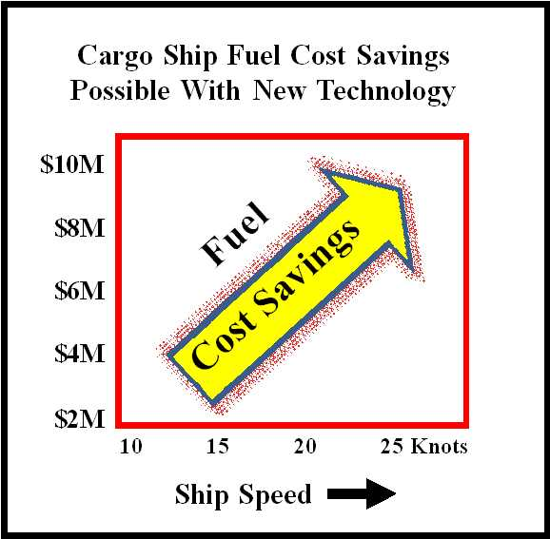

(1888 PressRelease) New technology can result in 10% to 30% fuel cost savings, allowing engines to use the same fuel, but at much higher fuel conversion efficiency.

New York, NY - Fuel conversion efficiency is a measure of how effectively fuel is transformed into usable energy. Each type of fuel has a specific energy-producing potential per unit of weight, but some or most of that potential is lost in existing internal combustion engines.
While 100% efficiency is always the goal, in practice the fuel conversion efficiency of most engines is very low, in the range of 20% to 30%. This is particularly true for internal combustion engines. After more than 100 years of technology development, automobiles rarely boast better than 20% fuel conversion efficiency. Cargo ships use larger engines which can have very low fuel conversion efficiencies. Clearly, there is room for improvement. Increasing fuel conversion efficiency translates directly to decreasing fuel costs.
A known method to increase fuel conversion efficiency is to add a small amount of hydrogen to the fuel. This works well for small engines, but the amount of hydrogen needed can make this method impractical for large engines because of on-board storage of hydrogen. The new technology can generate hydrogen at ANY rate (liters per minute), limited only by the hardware design. The result is that two problems have been solved -- delivery of hydrogen at high rates and producing it on demand, so that hydrogen storage tanks are not required.
The new technology, called Catalytic Carbon Hydrogen On Demand, CC-HOD, can produce hydrogen at the rate needed to obtain a 10% to 30% fuel cost savings for internal combustion engines. This new technology works by simply adding a small amount of hydrogen to common fuels so that engines can continue to use the same fuel, but at much higher fuel conversion efficiency.
The materials needed to produce hydrogen using this method are only scrap metal and water. The good news is that this can be sea water. Distilled water is not needed for the CC-HOD method of producing hydrogen.
This new method is energy efficient. CC-HOD is the only technology, worldwide, that can generate hydrogen at any rate desired using less energy than the useful energy released when the hydrogen is used (combusted or burned).
If the hardware is designed to operate at thermal equilibrium, input power is needed only during turn-on and heat-up, when the hydrogen-producing cell is heated to approximately 180F. After heating the cell, hydrogen can be produced at any rate desired, with no more input power required to operate the cell. The chemical reaction is exothermic (produces some heat) and that can be used to offset cooling of the cell during operation.
Generating the hydrogen at the rate needed, when and only when needed, is a requirement for new system engineering studies based on the use of hydrogen to obtain fuel cost reduction for cargo ships.
Why hasn't hydrogen been used to obtain large fuel cost savings?
Storage of large volumes of hydrogen is neither practical nor is it safe, particularly on cargo ships and tanker ships. The use of hydrogen on demand (CC-HOD) eliminates the cost and need for storing hydrogen in tanks.
The new CC-HOD process can produce hydrogen at very high rates. The world's first 30 gallon-per-minute process using catalysts for producing hydrogen-for-fuel was recently demonstrated by Phillips Company. This demonstrated breakthrough in hydrogen production was the basis for the first Hydrogen Design Conference held recently to focus on Hydrogen-for-fuel CC-HOD equipment design.
Historically, electrolysis is a method that has been used to produce hydrogen. Electrolysis is not a practical method for use on cargo-ship engines. Electrolysis would require thousands of Amperes of electrical currrent to produce hydrogen at the high rates needed for fuel cost reduction in cargo ships.
An important characteristic of this new breakthrough is that CC-HOD requires no external power input after the hydrogen-producing reaction is started, making possible, for the first time, the scale-up to high rates of hydrogen on demand (HOD) using water and scrap materials for fuel.
Using hydrogen produced with this new method, test vehicle data has shown a fuel cost reduction and a mileage improvement of 32% for smaller engines. These results are documented online. The next step is to prove that this new method can be used in much larger engines to obtain fuel cost reduction.
How much fuel cost saving can be obtained using this new method?
The cost savings can vary depending on fuel type (bunker fuel or diesel). The fuel consumption rate depends on the size of the cargo ship and the speed of the ship. These operational variable factors are considered in a new engineering study and cost analysis in which fuel cost-saving calculations assume a ship described as follows: 21 knots; 8000 TEU ship size; fuel consumed = 150 tons/day; ship in route 300 days per year. For such a ship, this new method offers the possibility of achieving a net fuel cost savings = approximately $8 million USD per year. This method for obtaining fuel cost savings is described in a document available online at http://www.PhillipsCompany.4T.com/AP.html
This new method is available now for fuel cost reduction
A growing number of equipment manufacturers are planning the commercialization of this new method for producing hydrogen fuel at high flow rates by extracting hydrogen from water, using scrap paper and scrap aluminum, two of the world's safest and lowest-cost industrial materials.
This new method is available to any company that needs a hydrogen production process that uses more water than scrap materials. The scrap materials do not have to be pure, making the materials less expensive. The hydrogen production process can operate using non-corrosive pH-neutral water, even if it is dirty, and can operate using sea water, the most abundant source of hydrogen on earth.
More information: www.PhillipsCompany.4T.com/AP.html

###

