Focus On The Addiction Recovery Path With Muskoka Recovery Center
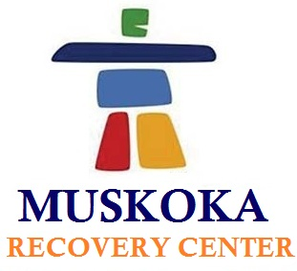

(1888PressRelease) Is continuous drug or alcohol abuse making you insane? Worry not; Muskoka Recovery Center is here to help you get rid of addiction with effectual recovery programs.

(1888PressRelease) Muskoka Recovery Center is a recognized name for addiction recovery treatment in Canada. Coupled with highly professional physicians and counselors, we provide rehabilitation program to overcome almost every kind of addiction, be it alcohol, drug or Methadone. In order to give an addiction-free and flourishing life to the addicts as well as to their families, we make sure that our patients receive supreme quality treatment. Thus, we mainly focus on personalized recovery treatment programs as we understand that no two persons are alike.
At Muskoka Recovery Center, our main focus retain on offering timely and effective treatment programs consorting from counseling to after care guiding tips. Our recovery programs starts with a thorough discussion with the individuals as to understand and develop a sincere customized treatment plan according to each individual case complexity. This individualized treatment program helps in availing highest probabilities for long-term sobriety achievement.
Besides addicts, we also provide quality services for the family members who are dealing difficulties while handling their loved ones addiction issue. We proffer elite amenities along with result-oriented treatment programs to let our patients feel comfortable as well as recover quicker. Moreover, with evidence based treatments and holistic services such as Reiki and massage therapies, Muskoka Recovery Center has remarkable success rate. To maintain the leadership of being one of the best rehab centers in Canada, we offer guarantee success result for every recovery program.
Muskoka Recovery Center is spread over an area of 100 acres in Muskoka. John H, the founder and Executive Director of Pickerel Lake Recovery Center, have commenced the planning about his dream project in 2005. Three years later, with extensive hard work and comprehensive research, he finally came up with Muskoka Recovery Center.
Today with extremely dedicated and passionate staff members, Muskoka Recovery Center has become leading drug and alcoholism rehabilitation center in Canada. The dedicated and professional staff includes:
• Physicians specialized in addiction medicine
• Psycho-therapists
• Certified addiction therapists
• Spiritual health counselors and more
Hence with highly professional staff, effective treatment plans, resort-like services such as gym, indoor pool, lounges etc, Muskoka Recovery Center assist addicts to get rid of addictions and live a healthy life.
To get more information or in case of any further assistance, you can contact us through email at info ( @ ) muskokarecovery dot com Or call us at 1-877-966-6887 dot
http://www.muskokarecovery.com

Trackback URL:

http://www.1888pressrelease.com/focus-on-the-addiction-recovery-path-with-muskoka-recovery-c-pr-410044.html

###

