A Legacy Of Quality To Suit Every Customer

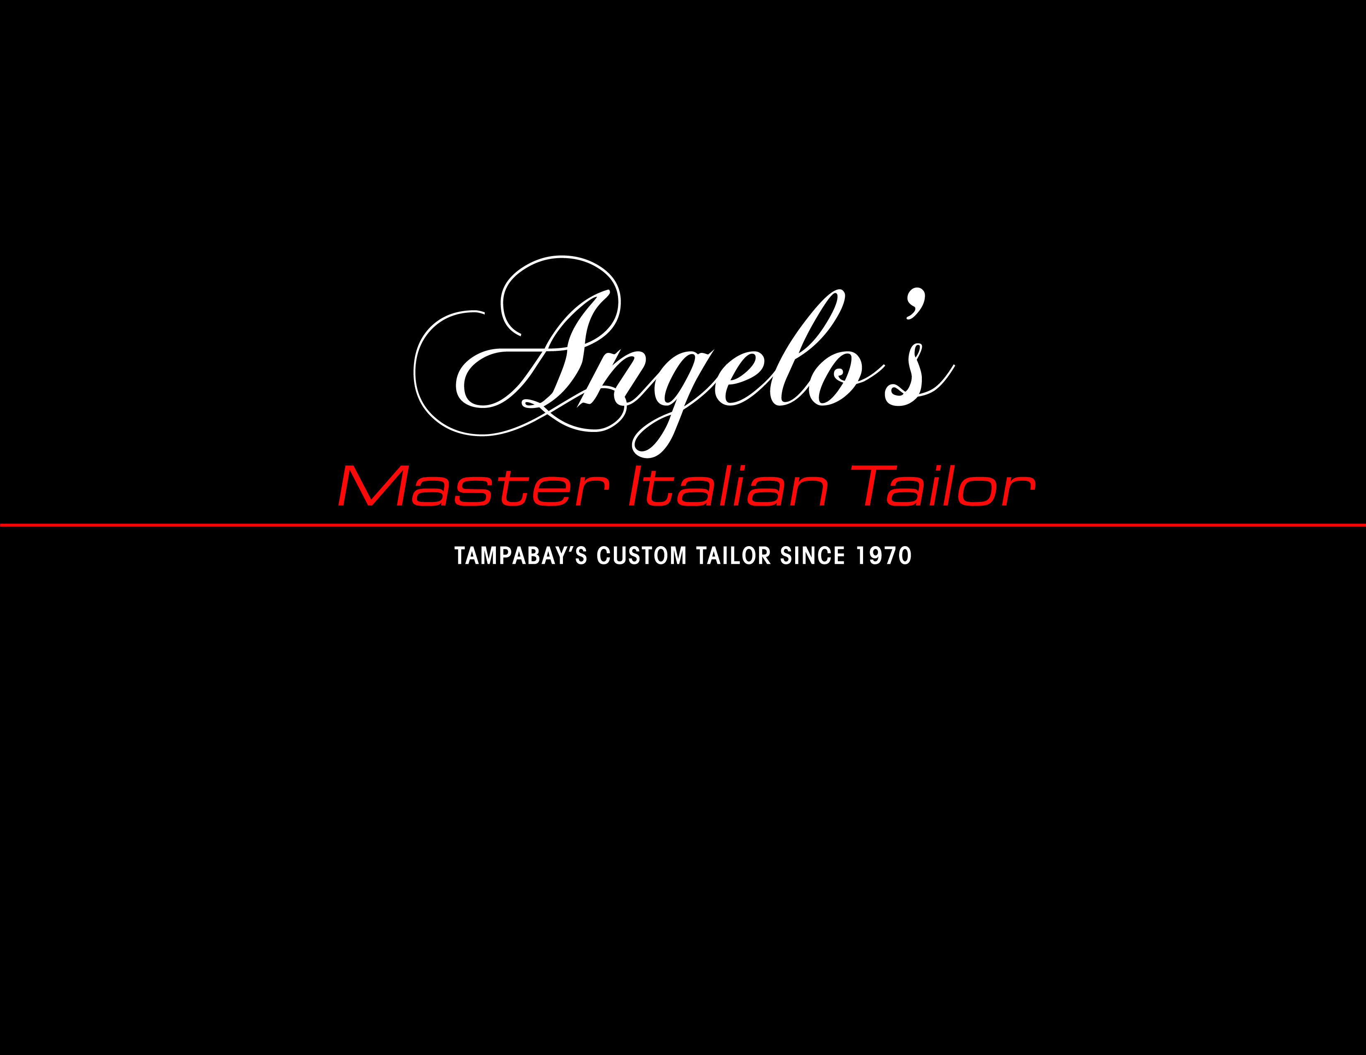

1888PressRelease - Angelo's Bespoke Clothing & Master Italian Tailor

Tampa-St. Petersburg-Clearwater, FL - PALM HARBOR, FL - They say clothes make the man - but what about the man who makes the clothes?
For more than four decades, Angelo DePergola has built a reputation in Pinellas County, designing suits and business attire at Angelo's Bespoke Clothing. Since 2007, his shop has been tucked inside the Commons at Twin Lakes shopping plaza off U.S. 19 North in Palm Harbor behind the Outback Steak House.
DePergola's meticulous attention to detail comes from a childhood spent apprenticing in Italy. But his customer service comes from his heart, from a love of seeing people look their very best.
"There's a lot of people in the area here that are still looking for a tailor like me and don't know I'm around. When they do find me, they all ask the same question - 'How come I never knew you before?' I say I don't know, I've been here 43 years. They all say the same thing - 'I've had other people make clothes for me, nothing but a disaster.' My answer to them is you have not dealt with tailors, you have dealt with sales people. Now you're dealing with a true master Italian tailor!"
At an unprecedented point in history, with more Americans looking for work than ever before, DePergola's shop is able to provide a variety of services - both for those already employed and those trying to find a job.
Angelo's Bespoke Clothing not only offers handcrafted suits, but a wide selection of ready to wear garments from suits, shirts and sport coats, each personally altered for free to ensure the absolute best fit. DePergola understands not everybody can afford a $4,000 suit, but that doesn't mean his customers can't look like they're wearing one.
"A lot of new customers that come to see Angelo, they come in for the custom-made suit or sport coat. When Angelo sees them and says, 'I can fit you in a ready-made suit much less expensive,' they can't believe it! Instead of buying one suit for the price, they buy two suits instead of a custom-made and they really appreciate that!"
DePergola also offers alterations on previously worn garments that no longer fit just right. For customers on a tight budget, it can mean the difference between looking shabby or chic without breaking their wallet.
If you want to look your best, and you need to do so in order to impress, there's only one master Italian tailor in Pinellas County who can help you do so - Angelo's Bespoke Clothing, 31960 U.S. Highway 19 North, Palm Harbor, FL 34684.
Open six days a week at 11 a.m., with convenient after-hours and Sunday appointments available by request, Angelo's Bespoke Clothing is the business professional's destination for attire that leaves an impression.
"I have a saying, I wrote this in 1971 - The quality is long remembered after the price is long forgotten. That's my saying."
To see more about Angelo's Bespoke Clothing now, see the video on his website at: http://www.angelosbespokeclothing.com/#!video/c3op
For more information, or to schedule an appointment, please call Angelo DePergola at (727) 777-6070, or visit us online at www.AngelosBespokeClothing.com .

###

