Name of Game | Best World Clock
Email | app_support@rvappstudios.com
Publisher | RV AppStudios
Summary Description | Do you have Friends & Family in Multiple Cities around the world? Have you thought about calling them but were unsure what time it's in that time zone? Download Best World Clock and you can easily get the exact time for that particular city.
Size (MB) | 1 MB
Version | 1.0.0.0
App Category | Tools +Productivity
Screen shot | 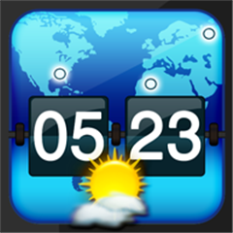
Price | Free
App Url |  | http://www.windowsphone.com/en-US/apps/52058b83-84be-41d4-b466-80db7e95a068
Requirements | Windows Phone 7 or higher
Languages | English
Release Date | 5/04/2012
Full Description | “Get Time of Multiple Cities With Single Tap!”  “NO INTERNET REQUIRED”  Do you have Friends & Family in Multiple Cities around the world? Have you thought about calling them but were unsure what time it's in that time zone? Download Best World Clock and you can easily get the exact time for that particular city. You never know when this could be useful, so download it today!  Call your friends, family, or even clients without having to worry if you're going to wake them up. Simply open up the app and check. No more having to hear from your friends that did you know it's 2:00 AM.  Best World Clock allows you to add multiple countries with global time as per GMT time zone without using internet. Create your own list to get actual time of your preferred cities with day & night condition and country flag. Easily add and remove cities in user-friendly interface. Download Best World Clock today!

