Muskoka Recovery - Take One Step Towards Healthy Living
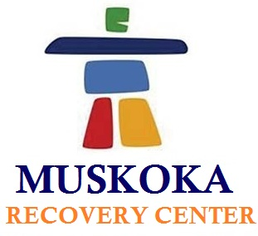

(1888PressRelease) We all know that addiction to drug or alcohol is always hazardous to health. So it is better to get rid of it and live a healthy life. If you are looking for rehabilitation in Ontario then Muskoka Recovery Center is here to help you.

There are many people suffering from addiction problem and they usually do not realize what they are doing. Regular intake of alcohol or drugs could reach to an extreme point and it can be quite hazardous. Addiction can result into severe problems. The chemical substances get dissolved into the blood and brain barrier and then it can vary the balance of the brain. Muskoka Recovery Center is very well known for its facilities and methods of handling various types of addiction. We also provide counseling and treatments to the patients. A team of highly skilled experts are holding the expertise in their area. Muskoka Recovery Center offer treatments to patients that are suffering from drugs or alcohol addiction. Muskoka Recovery Center is known as the best Rehab center in Ontario. We are providing various treatments depending upon the situation of the patients. The progress in health of the patient can be seen with routine and professional counseling.
There are many highly skilled professionals at Muskoka Recovery Center that are taking the process of recovery to the path of success. We provide best facilities and latest treatments to our patients for comfortable procedure that also helps in recovering faster.
Muskoka Recovery Center is situated over an area of 140 acres on a land of serene beauty in North Muskoka/Parry Sound. The Founder & Executive Director of Muskoka Recovery Center, John, began to develop the design and model for an addiction treatment Center. Then after 3 years of hard work and thorough research he came up with Muskoka Recovery Center. Now with advance treatments and regular counseling we are helping many people to beat their addiction problem.
We have a team of professionals that are holding expertise in their work area. The experts in Muskoka Recovery Center are such as specialization in medicines for addiction, psycho-therapists, certified addiction therapists, spiritual health counselors.
We have the staff that works with complete dedication and sincerity to provide best and latest services. The main purpose of Muskoka Recovery Center is to make the patients feel comfortable and healthy. In our recovery center you will get all the facilities such as gym, indoor pool, lounges that can help you to achieve the main goal etc.
To get any more information about the recovery treatment programs or any other services contact Muskoka Recovery Center at 1-877-966-6887 or at info ( @ ) muskokarecovery dot com dot
http://www.muskokarecovery.com

###

