Name of Game | Best Pill Reminder - Plus Weekly Task Reminder
Email | mary@rvappstudios.com
Publisher | RV AppStudios
Summary Description | Do you have to take lot of medicines or supplements? If yes, then Best Pill Reminder will help you to make a schedule, for when to take the medicines by reminding you on selected day and time.
Size (MB) | 13.5 MB
Version | 1.0
App/Game Category | Utilities
App/Game URL | http://itunes.apple.com/us/app/best-pill-reminder-plus-weekly/id543116146?ls=1&mt=8
Apps Logo | 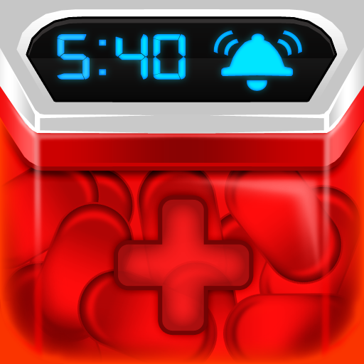
Price | Paid
Languages | English
Release Date | 06/08/12
Full Description | ★ Do you have to take lot of medicines or supplements? If yes, then Best Pill Reminder will help you to make a schedule, for when to take the medicines by reminding you on selected day and time. ★  ★ Do you have weekly tasks or daily things you want to do? Maybe you need to do your physical therapy exercise every 3 hours, no problem add it in the Best Pill Reminder. You can pretty much add anything you want in the Best Pill Reminder! ★  Remembering the names of prescripted medicines and schedules for taking them can be little bit confusing, if done orally. Adding information like name, type of dosage, frequency and duration of your medicines in Best Pill Reminder app will give you one click access to check the whole schedule, anytime and anywhere.  ★ Key Features:  ✓ Schedules various reminders by adding details into the pillbox  ✓ History tracking of previous medications that can help you to refer in future  ✓ Pleasant reminder sounds to remind you to take medicines  ✓ Add comprehensive notes on medications and pills log to get in-detail information  ✓ Share your medicines  ✓ Different types of reminders based on hours, number of days, daily, on specific dates, weekly, or on a specific day of the month, or even on a specific week of the month  Best Pill Reminder is an essential application for managing all required medications. Now, you’ll by no means miss one more planned time to take your medicine.  ▲▲ We look ahead to help you in taking your medications regularly, each time with this Best Pill Reminder App. ▲▲
Screen Shots | 