Frontline Source Group Staffing Agency Passes 100k Facebook Fans
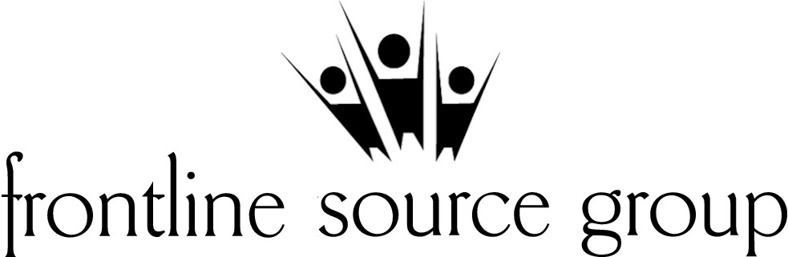
(1888PressRelease) Frontline Source Group, Inc., has announced the passing of a major milestone in social networking for the employment staffing industry. The premier temporary staffing and direct-hire placement agency announced that their Facebook fan page has surpassed 100,000 fans and is still growing each day.
(1888PressRelease) - Dallas, TX - President and CEO, Bill Kasko, of Frontline Source Group, Inc., has announced the passing of a major milestone in social networking for the employment staffing industry. The premier temporary staffing and direct-hire placement agency announced that their Facebook fan page has surpassed 100,000 fans and is still growing each day. The organization specializing in the placement of professional Accounting/Finance, Information Technology, Human Resource, Administrative, Clerical, Medical Front Office, Legal and Oil and Gas professionals continues to break records and excel in the social networking arena. Kasko said, "People within the industry have been telling us that we would never reach 100,000 fans on Facebook. We launched our facebook page on January 1, 2010 and on June 18, 2012 we officially passed the 100k mark and our fan page is still growing. At this point who knows how many people we can connect with and help with respect to their job, career and employment search needs." Kasko went on to say, "we continue to prove our critics wrong time and time again when it comes to social networking, both Facebook and Twitter, videos and just how important all of this is to the employment staffing industry and job community. With the recent launch of our staffing apps for the iPad, iPhone, and Android phone, we have shown that we continue to look for new and innovative ways to spread the work to potential candidates and employers about our services and work that we do each day. We are not your average staffing agency and we will continue to work outside the box to spread the word about temporary staffing, direct hire employment, jobs and career opportunities via whatever media is necessary or resource is available."
"Facebook has given Frontline a great opportunity to reach a vast number of people worldwide and this social network will continue to help us grow outside of Texas for years to come. Social networking is here to stay and we have always been on the frontline of new methods of communication to both the candidate and the employer. This has proven to be a wonderful way to communicate with our audience. ", said Shelly Hubble, Vice President of Client Partnerships & Development. "From the onset of YouTube, Twitter and Facebook, or our ability to attract people to follow us and learn about career opportunities has been incredible. We have always worked to enlighten the public about the staffing industry and temporary staffing opportunities. Each day we work hard to put people back to work with great companies in new career opportunities. We strive to that make a difference one person at a time and having a resource like our Facebook Fan page has proven to be a wonderful tool that we utilize each day."
For more information about Frontline Source Group's services, a link to our Facebook, Twitter, YouTube, iPad, iPhone and Android App, please visit our website at http://www.frontlinesourcegroup.com
About Frontline Source Group, Inc.
Founded in 2004, Frontline Source Group is one of the fastest growing staffing agencies for Technical Services, Information Technology, Accounting Finance, Human Resources, Legal, Administrative, Clerical, Medical Front Office and Energy, Oil and Gas staffing. Frontline specializes in matching top talented professional candidates with companies for temporary, temp to hire, temp contract, and direct hire placement positions.
SMU awarded Frontline Source Group, Inc. the Dallas 100 award in both 2008 and 2009. The Dallas Business Journal has named Frontline Source Group, Inc. as Dallas/Fort Worth's "Best Places to Work" in 2007, 2008 and 2010. The American Staffing Association awarded Frontline Source Group, Inc. the coveted "2008 Voice Award" for Best Overall Communication within the staffing industry and numerous Communication awards in 2010 for Facebook and Twitter utilization. Current office locations: Dallas Fort Worth Austin Plano Houston Sugar land The Woodlands, Texas - Nashville, Tennessee and Phoenix, Arizona.
Frontline Source Group, Inc. - Corporate Office
311 N. Market Street, Suite 200
Dallas, TX 75202
214-744-5627
Trackback URL:
http://www.1888pressrelease.com/staffing-agency/temporary-agency/frontline-source-group-staffing-agency-passes-100k-facebook-pr-312038.html
###

