Paul Chehade a different better path.

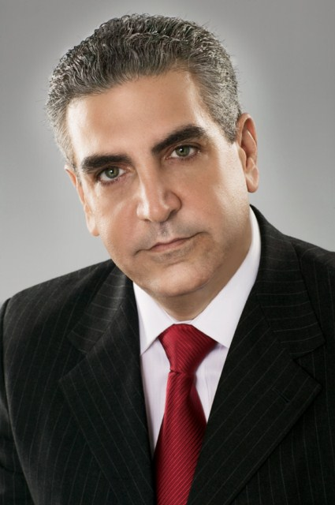

1888 Press Release - The divisions in the existing political parties are leading to a government deadlock, which can only be broken by a candidate from outside the establishment. Paul Chehade.

Paul Chehade a different better path.
My fellow Americans:
You know that I am an optimist, and I will always place my faith in God and the relentless spirit of the American people. I have always believed that our best days are yet to come; we only need to work together to achieve a brighter tomorrow. However, there is even more reason now for others to share my optimism.
In a Gallup poll released recently, the percentage of Americans who identify as Independents surged to 42%, the highest level in the quarter century since Gallup has been conducting interviews by phone. Why is this so?
Loyalty to party and to ideology has prevented members of Congress from working together. To the average American, it appears that politicians are more interested in upstaging the other party than in actually solving the problems faced by this great nation. And that is not just my opinion.
In a poll conducted by CNN/ORC International, two-thirds of those questioned said this Congress is the worst one in their lifetime. That is staggering number, and it highlights the level of dissatisfaction with the current two-party political system.
We are much more alike than we are different, and we must overcome these small differences to present a united front for the sake of America. Let us focus on all that we have in common, not the few things on which we have differing views
Americans have a right - and an obligation - to demand more of their elected representatives. If the old labels of "Democrat" and "Republican" are only used as an excuse to oppose good, common-sense legislation simply because it comes from the other side of the aisle, then perhaps it is time that we abandon the right and the left, and focus instead on a different, better path.
And this is the reason that we are hopeful. The time has come to move away from establishment candidates to one who has the honor and integrity to lead the conservatives in America back to their rightful place as leaders of this country.
Please join me as an independent candidate for the Presidency of the United States, and together we can bring conservative values back to the forefront of American politics.
God Bless America.
Paul Chehade:.
Honor and Truth
For more information please visit: http://www.paulchehade.org
Follow Paul Chehade on Facebook: https://www.facebook.com/paulchehadeII
Follow Paul Chehade on Twitter:https://twitter.com/paulchehade
###

