Name of Game | Easy To Do
Email | mary@rvappstudios.com
Publisher | RV AppStudios
Summary Description | Easy To Do helps create categorized list of things To Do & with color coded priorities. It's extremely easy to, use and with a user-friendly interface. This is the easiest To Do you can use and will work great for everyone.
Size (MB) | 7.1 MB
Version | 1.0
App/Game Category | Productivity
App/Game URL | http://www.amazon.com/RV-AppStudios-Easy-To-Do/dp/B008Y0SIWK/
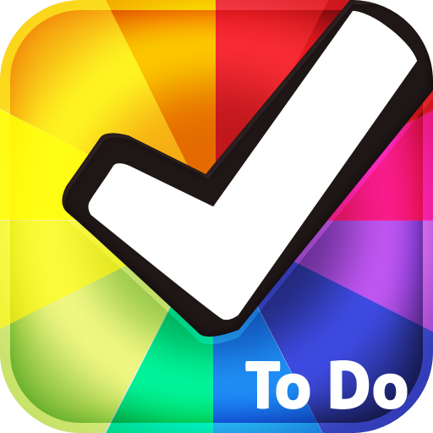
Apps/Games Logo
Price | Free
Languages | English
Release Date | 22/08/12
Full Description | Easy To Do helps create categorized list of things To Do & with color coded priorities. It's extremely easy to, use and with a user-friendly interface. This is the easiest To Do you can use and will work great for everyone.  Features  - Add, Edit & Delete To Do from Lists  - Notification for Upcoming To Do Tasks  - Adjust Task Priority With Simple Drag  - Choose Different Color Themes  - Share on Twitter & Facebook  Easily manage your To Do today!
Screen Shots | 