Wholesale Oxytocin Spray - New websites launched from UK

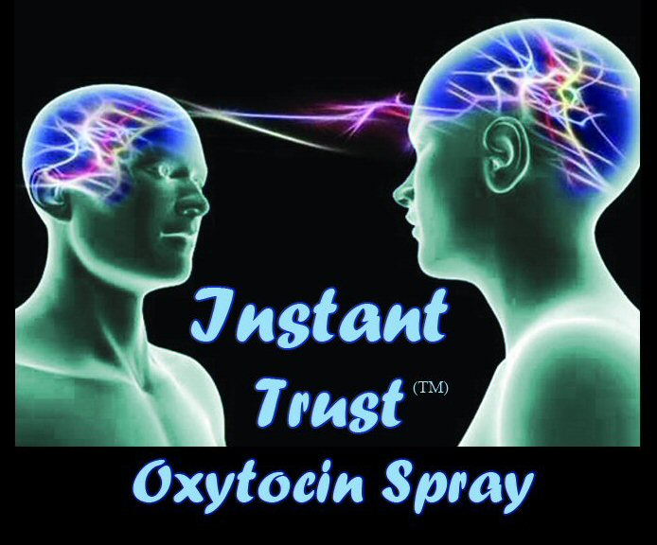

(1888PressRelease) New Instant Trust™ Oxytocin spray has been launched at wholesale and retail websites at newly competitive pricing for worldwide delivery.

Oxytocin sprays have recently become in demand as a flurry of media stories have reported on cutting edge scientists' investigations into the properties of Oxytocin in creating confidence and social bonding.
Oxytocin has been named the "Cuddle Hormone" and is a hormone released in the brain as a result of intimate contact. Research is now showing that this hormone creates an emotional warmth and feeling of confidence and trust.
A new brand of Oxytocin body spray in 50ml bottles has been launched from the UK by a company that operates from www.21stcenturyalternatives.com which specialises in anti aging products that have been researched by cutting edge scientists. Their slogan is "Keeping Ahead of the Mainstream"
The new Oxytocin spray is called Instant Trust™ and is available for retail buyers at www.instanttrust.co.uk at a very competitive price compared with the few existing brands available or for wholesale buyers athttp://www.oxytocinwholesale.co.uk with a minimum order of only 12 bottles.

###

