Name of Game | GameBundle - 4 Games in 1
Email | app_support@rvappstudios.com
Publisher | RV AppStudios
Summary Description | Game Bundle is the perfect game pack for you & your family. Everyone can play these fun casual games, young and old. So what are you waiting for download it today and see for yourself.
Size (MB) | 9 MB
Version | 1
App Category | Entertainment
Screen shot | 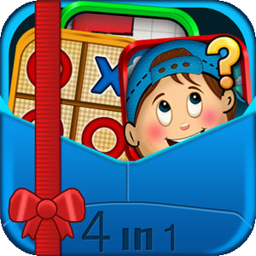
Price | $ 0.99
App Url | http://www.barnesandnoble.com/w/books/1110266378
Languages | English
Release Date | 18/04/2012
Full Description | Game Bundle is the perfect game pack for you & your family. Everyone can play these fun casual games, young and old. So what are you waiting for download it today and see for yourself.  The bundle includes fun casual games that are great to play when you have a few minutes spare and want to relax.  -Games Included Within Bundle  1) CATCH a TOY (Memory Game)  2) Chain Explosion  3) Doodle Tower  4) Tic Tac Toe  ::: Take A Closer Look At Our Games :::  CATCH a TOY  Simple yet challenging & funny memory match game. Timing & your short-term memory are the key to winning. Simply tap & select an object and then open another object to match. The game has multiple levels of game play and some interesting powers for added fun & challenge. Improve your memory and keep your kids busy, it's fun for all ages.  Chain Explosion  Play this extremely simply, but yet amazing fun Chain Explosion game. The game is beautifully placed in a chemistry background & balls are moving around in random directions and you've got to smartly decide the chain explosion starting point. If you can get the number of targeted explosions to occur then you've passed the level! Can get addicting! Chain reaction will enthrall you but yet challenge you. You get just one tap to start the chain ball explosion, so be wise and try to time it perfectly. See if you have the skills to continue going as the game progresses.  Doodle Tower  You've to a limited time to stack the shapes to a set height. The game requires you to judge the best location to place the shapes to reach the desired height. You have multiple shapes and obstacles in the way so it can get challenging!  Real physics elements are built into the game, and so if you place the shapes at the wrong place then watch them tumble to the ground. The game is simply but can provide hours of fun. Do you have the skills to build the tower? Play and find out :-)  Tic Tac Toe  The classic game is a great when you have a few minutes. Just relax and play, it never gets old playing this. The best part is that you can play against the computer or your friends on one device.  Get 4 games bundled into one for a low introductry price of only $0.99. The bundle was specifically optimized for the NOOK. So have fun and enjoy this game bundle today!

