Get the sober life back with Muskoka Recovery Centre
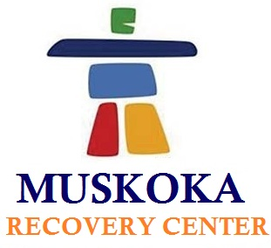

(1888PressRelease) Dealing with any kind of addiction and looking for a rehab center to get back the sober life again, then Muskoka Recovery Centre is the name that helps you get rid of addiction effectively and successfully.

Muskoka Recovery Centre, located in North Muskoka, is a beautiful rehab center with almost 140 acres of complete serenity, offering solution focused treatment programs to get rid of alcohol, drug and Methadone addictions. Being one of the leading names for rehabilitation centers in Toronto, Muskoka Recovery Center offers effectual and result-oriented treatment programs. The treatment programs covers alcoholism, drug addiction, Methadone addiction, as well as different disorders like mood swings, dual personality, eating chaos.
The treatment programs at Muskoka Recovery Centre are personalized and provided only after an intervention with the individual as to understand the actual cause of the addiction as well as further essential requirements towards recovery. Muskoka Recovery Centre proffers world-class attention to every patient; moreover all these recovery programs are coupled with wide range of holistic services like message therapies and Reiki, etc.
As to make every recovery program more helpful and successful, Muskoka Recovery Centre has team of extremely proficient and trained physicians. Besides their skills and accomplishments, most of the staff here is recovered or still recovering from some addiction, thus provide modesty and integrity while serving others. In nutshell, Muskoka Recovery Centre provides tailored recovery programs as per every individual's need coupled with latest techniques under strict guidance of veteran staff.
John, the founder and executive director of Muskoka Recovery Centre have started the project in 2005. With three years of constant and severe hard work, he landed with Muskoka Recovery Centre in North Muskoka. This center has almost 140 acres of area that serves high level of privacy, peace of mind and security to every patient. Moreover, the rehab center offers top-notch services to all its patients as well as their family members as to make the recovery program productive for them as well. Muskoka Recover Centre provide high quality amenities like fishing, canoeing, lounges, private rooms, meeting halls, gym facilities, indoor pool, hot tub and so on.
As mentioned earlier, the staff at Muskoka Recovery Centre is highly skilled and professional that includes:
• Physicians who specialize in addiction medicine
• Psycho-therapists
• Certified addiction therapists
• Master's level therapists
• Intervention counselors
• Anger Management specialist
• Relapse prevention counselors
• Spiritual health counselors
• Life skills coach
• Therapists with specialized crisis management
• Massage and Reiki masters
With veteran staff, top-notch facilities and effective recovery programs, Muskoka Recovery Centre's program provides the highest success rate in Toronto.
To know more about us or in case of any query, drop us an e-mail at
info ( @ ) muskokarecovery dot com Or call us at 1-877-966-6887 dot
http://www.muskokarecovery.com

###

