World's first hydrogen fuel demonstration using catalytic carbon
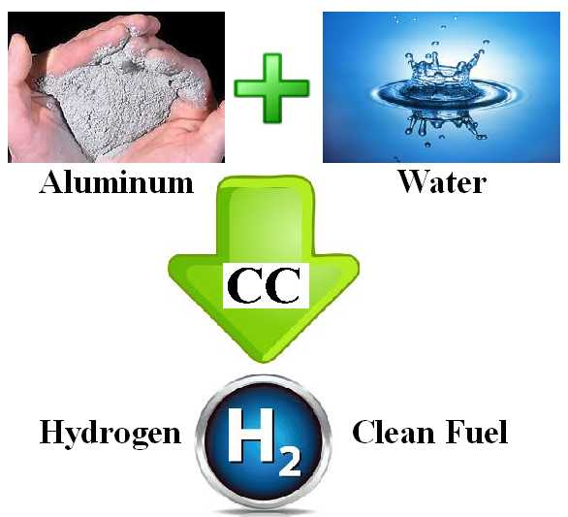

(1888PressRelease) The world's first prototype equipment using catalytic carbon for producing hydrogen-for-fuel will be shown publicly in London. On April 23, guests and VIP's, including political, business, academia and energy sector specialists and professionals are invited to challenge, discuss, analyse the world's first scalable Hydrogen-On-Demand system requiring minimum power input.
(1888PressRelease) Houston, TX - The demonstration will be shown in the presence of the Rt. Hon. Eric Pickles MP, Brentwood & Ongar, UK Secretary of State for Communities and Local Government. Bion Energy will show hydrogen-producing equipment to demonstrate and validate this new breakthrough, using catalysis to produce hydrogen having more energy content than the energy required to produce the hydrogen. More information about this meeting is available online at www.biongroup.co.uk or by contacting fred.davey ( @ ) biongroup dot co dot uk via email dot
An important characteristic of this new breakthrough is that it requires no external power input after the hydrogen-producing reaction is started, making possible, for the first time, the scale-up to high rates of hydrogen on demand (HOD) using catalytic carbon.
A growing number of equipment manufacturers are planning the commercialization of this new low-cost, safe method for producing hydrogen fuel at high flow rates by extracting hydrogen from water, using carbon and aluminum, two of the world's safest and lowest-cost industrial materials. Bion Energy will use a worldwide central licensing agent to rapidly license this new technology.
Experts agree that hydrogen will command a key role in future renewable energy. For years, the world's clean-energy goal has been to have a relatively cheap, safe, efficient and non-polluting means of producing hydrogen on demand, at very high rates which make hydrogen storage tanks unnecessary. That goal has been met, for the first time, using a new process using safe, low-cost activated carbon. The new catalytic process is based on chemistry theory that is developed and ready for commercialization. "We are in discussion with potential licensees. Business agreements with additional licensees, particularly manufacturing companies, are planned," said a company spokesman.
Catalytic chemistry research resulted in the discovery that an inexpensive activation process can convert normal carbon into a carbon catalyst that can effectively generate hydrogen gas from water, using a small amount of aluminum. The process does not consume the catalytic carbon. The process uses more water than aluminum, and the aluminum does not have to be pure, making the fuel less expensive. The carbon catalyst does not require electrolytes or organic additives. It can operate in pH-neutral water, even if it is dirty, and can operate in sea water, the most abundant source of hydrogen on earth.
Hydrogen is an energy dense and clean fuel, which upon combustion releases only water vapor. Today, most hydrogen is produced from thermoforming and electrolysis which require large amounts of electrical energy or from natural gas which results in excessive carbon-dioxide emissions. An alternative, clean method is to make hydrogen from water. The new process is called CC-HOD, or Catalytic Carbon, Hydrogen on Demand.
Before this new process was developed, the use of hydrogen fuel was limited by the lack of a cheap catalyst that can speed up the generation of hydrogen from water. The new catalytic process is based on chemistry theory that is developed and ready for commercialization. "We are in discussion with potential licensees. Business agreements with additional licensees, particularly manufacturing companies, are planned," said a company spokesman.
Bion Energy is searching for companies that can produce hardware and commercialize the technology in the form of fuel for vehicles, hydrogen fuel for heating, and hydrogen fuel for water distillation. "We think using hydrogen to fuel ships is promising because the process works well with sea water. More importantly, we think it makes sense to use hydrogen to fuel electric power generators on islands or in remote locations where water is plentiful and cheap, compared to the cost of importing oil/diesel via tanker ships."
These applications are now possible because this process is the world's first method that can be scaled up to produce hydrogen on demand at very high flow rates using catalytic carbon. Because the hydrogen-producing process uses pH-neutral chemistry, the hardware corrosion problems are virtually nil. Scale-up calculations, showing the relationship between fuel consumed and hydrogen flow rate are given online at www.PhillipsCompany.4T.com/SU.pdf
"Introduction of this new technology will first be used as a fuel supplement to increase the efficiency and reduce the cost of existing petroleum fuels. This has been demonstrated by using hydrogen as a fuel additive in conventional automobiles to increase the mileage (miles per gallon) by more than 30% with no modification to the engine," said a company spokesman.
Bion Energy represents Phillips Company, the inventor of this new process for producing hydrogen. Carbon, the world's lowest-cost and best catalyst for producing hydrogen from water is described online at www.PhillipsCompany.4T.com/HYDROGEN.html
http://www.PhillipsCompany.4T.com
Trackback Url :
http://www.1888pressrelease.com/world-s-first-hydrogen-fuel-demonstration-using-catalytic-ca-pr-389299.html
###

