Microtrac Needed a Bigger Boat!

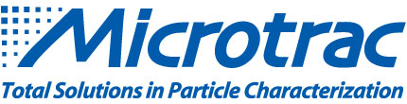

1888 PressRelease - Microtrac, the global pioneer of particle characterization has moved into a brand new corporate headquarters, located in the suburbs of Philadelphia, PA.

Microtrac, the global pioneer of particle characterization is proud to announce that they have relocated to a new corporate location.
215 Keystone Drive, located in scenic Montgomeryville, Pennsylvania is an ideal office space for Microtrac's corporate headquarters. Situated in close proximity to Route 309, the Pennsylvania Turnpike, and the Philadelphia International Airport, the location is convenient for employees and visitors alike. The facility will house the company's Engineering, Research and Development, Marketing, Accounting, and Administration functions.
The new office space is double the size of Microtrac's previous location and provides the employees the space necessary to continue to develop pioneering solutions and products.
Paul Cloake, Microtrac President says " Microtrac's roadmap for growth will require strategic additions to our R&D, Engineering, and Marketing staff. The new headquarters will provide more space and a better environment for our people, our most important resource, as we drive to provide our customers with innovative and cost effective solutions to their particle characterization needs."
For further information please visit http://www.microtrac.com. Stay up to date with the latest innovations from Microtrac, by signing up for our monthly eblast at Microtrac.com/newsletter.
###

