Cowichan River Tubing - Grand Opening 2010
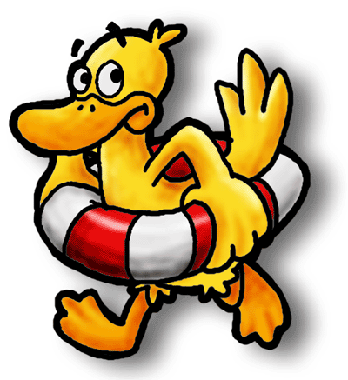
(1888PressRelease) The Lake Cowichan Adventure Company, aka "The Tube Shack" announces the grand opening of it's new location in Lake Cowichan, BC at 122 Southshore Rd in the heart of downtown Lake Cowichan. The Tube Shack is fully licensed and insured and is Lake Cowichan's only All Inclusive river tubing adventure company.
(1888PressRelease) July 07, 2010 - For most people summer time and water just go hand in hand and no summer is complete without spending part of it enjoying water sports. Thousands of people have already experienced the fun and excitement of tubing the Cowichan River, and if you've never tried this popular water sport, there's no better time than the present.
The Lake Cowichan Adventure Company, aka "The Tube Shack" announces the grand opening of it's new location in Lake Cowichan, BC at 122 Southshore Rd in the heart of downtown Lake Cowichan. The Tube Shack is fully licensed and insured and is Lake Cowichan's only All Inclusive river tubing adventure company.
The long hot, dry summers of the Lake Cowichan region make the crystal clear water of the Cowichan River an ideal place to spend the day. The Cowichan Valley is a glaciated valley that enjoys the warmest temperatures in Canada. The warm climate combined with all the natural water resources creates a virtual water sport paradise.
Cowichan River tubing is an island tradition that has been a favorite summer activity for both locals and visitors from far and wide for many years. Every year literally thousands of people join us and let the river take them on a tour of some of the most spectacular scenery in the world.
While tubing down the Cowichan River is a favorite activity for anyone that loves water sports, it's also a popular past time for anyone that loves nature. With every bend and turn of the river, you'll be guided along an eco-tour that you will never forget.
There's a wide abundance of various species of flora and fauna that grows along the rivers edge. From beautiful wildflowers to lush foliage, there's never a shortage on plant life. And, the stunning rock formations are a sight that you'll not see anywhere else on planet earth.
The dense forests that border both sides of the river are home to numerous species of wildlife. You may catch a glimpse of a deer or elk indulging in a cool drink of water along the rivers edge. And, your heart might pound at the sight of a bear or cougar watching you from the forests cover.
For more information on Cowichan River Tubing find us on the web at http://www.cowichanriver.com
Trackback URL:
http://www.1888pressrelease.com/cowichan-river-tubing-grand-opening-2010-pr-223593.html
###

