Boston Fire Department Chooses Radiation Shield Technologies' (RST) Demron To Improve Safety And Response

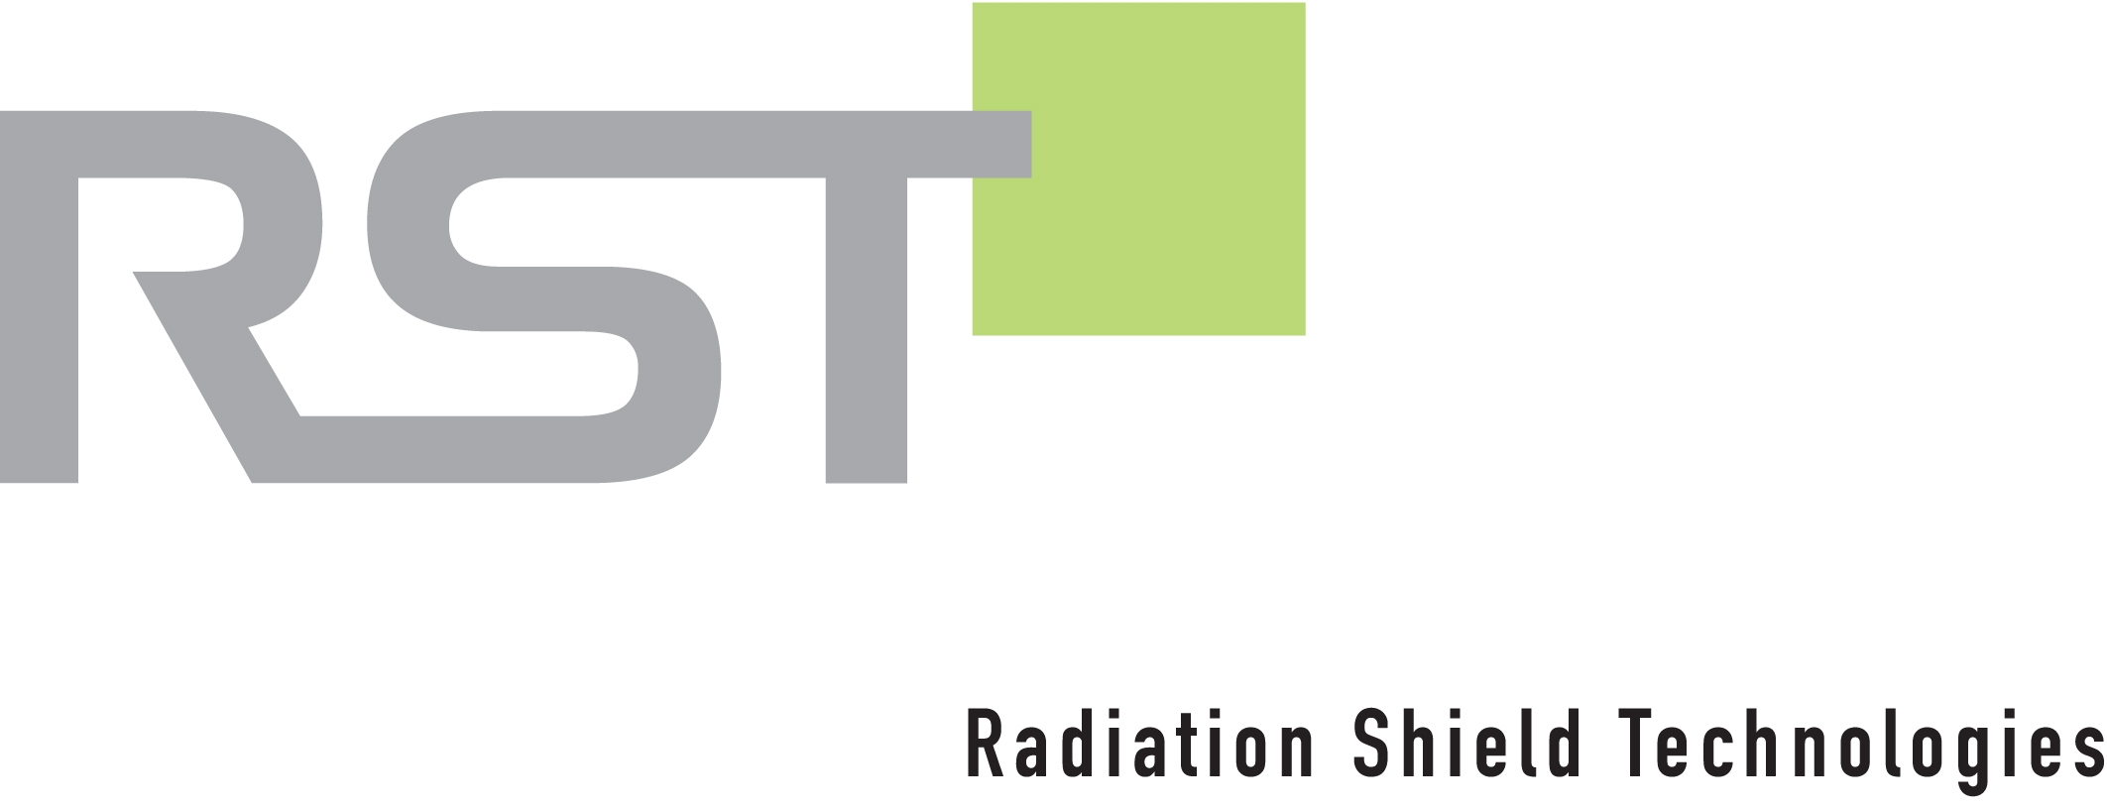

1888PressRelease - On May 3rd, 2012, The Boston Fire Department (BFD) had proactively acquired RST's High Energy Anti-Nuclear Improvised Explosive Devices (IED) Blankets. The Boston Fire Department (BFD) chose Radiation Shield Technologies' Demron as part of its commitment to improve response team safety and prepare themselves for future threats such as the events that had unfolded this week.

Miami, FL - The blankets combine ballistic fibers with Demron to provide the only Anti-nuclear IED blanket available, serving as a protective cover for first responders or as a suppression blanket for improvised explosion devices, radiological dispersal devices, and radiation assured devices. The blankets are certified by the National Institute of Justice (NIJ) with 0108.01 certification, significantly reducing High Energy Nuclear radiation such as Cs 137 by 70 percent or more. The shields, protected by US patent 8334524, are lightweight, easily deployable, and resistant to flame, chemical, and biological hazards.
"Our hearts go out to the victims and families of yesterday's tragedy," said Ronald DeMeo, M.D. president of Radiation Shield Technologies and the noted surgeon and entrepreneur who invented Demron. "As safety threats become more and more common, we continue to support the Boston Fire Department's mission to provide protection to the people of Boston."
About Demron and Radiation Shield Technologies (RST)
For more than 20 years, RST has pioneered high-performance, multi-hazard fabrics employing Demron for military, firefighters, law enforcement and medical personnel. Demron combines the metallic properties of gamma radiation reduction, trauma reduction and thermal conductivity with advanced nano polymer technology, and is uniquely capable of providing true anti-nuclear protection and heat stress reduction without compromising chemical or biological hazard protection.
RST was recently featured on hit TV show "Flashpoint" as well as every major news network world wide including Fox National News, CNN, MSNBC, HNL, ABC, CBS, NBC, AP and UPI.
Headquartered in Miami, FL, RST is an ISO 9001 & 13485 manufacturer and has received numerous awards including the NFPA 2007 Class 2 certification. Whether used in a warm or hot zone, Demron provides the ultimate in universal protection against all CBRN hazards. Demron's product line currently includes full body suits, blankets, tents, and other products that have been used worldwide by every branch of the U.S. military, U.S. CST teams, the FDNY, IAEC, DSTA, NASA, and many international first responder and military teams in China, Iraq, Kuwait, South Korea, Pakistan, UAE, Saudi Arabia, Vietnam, and Singapore. For more information please visit http://www.radshield.com, or call (866) 7DEMRON.

###

