Name of Game | Easy To Do
Email | app_support@rvappstudios.com
Publisher | RV AppStudios
Summary Description | Easy To Do helps create categorized list of things To Do & with color coded priorities. It's extremely easy to, use and with a user-friendly interface. This is the easiest To Do you can use and will work great for everyone.
Size (MB) | 10 MB
Version | 1
App Category | Business & Finance
Screen shot | 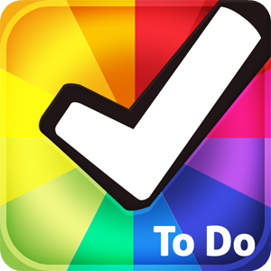
Price | $ 1.99
App Url | http://www.barnesandnoble.com/w/easy-to-do-rv-appstudios/1110593301
Languages | English
Release Date | 02/05/2012
Full Description | Easy To Do helps create categorized list of things To Do & with color coded priorities. It's extremely easy to, use and with a user-friendly interface. This is the easiest To Do you can use and will work great for everyone.  Features  Add, Edit & Delete To Do from Lists  Adjust Task Priority With Simple Drag  Choose Different Color Themes  Share on Twitter & Facebook  Easily manage your To Do today!

