John Rosatti Launches Latest World Class Super Yacht, Remember When
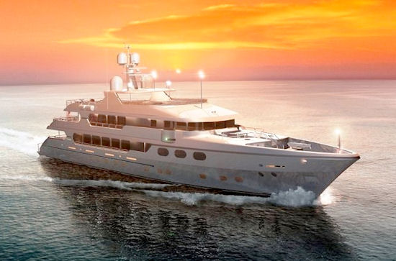
(1888PressRelease) John Rosatti new world class super yacht is top notch in safety and luxury. The 162' yacht offers under-floor heating in each of the marble bathrooms, air conditioning on the outside of all three levels!
(1888PressRelease) - New York, NY; October 13, 2010- Successful entrepreneur and yachtsman, John Rosatti recently launched his latest luxury yacht, Remember When. The yacht, built by Christensen Shipyards, is said to be the best Christensen built up to date. For those who desire opulence and safety on the water, John Rosatti's new luxury yacht is available for charter.
John Rosatti chose Christensen to manufacture the new super yacht for their superior craftsmanship and attention to detail. John Rosatti does not settle for second rate and Remember When is a perfect example of this unwavering desire for perfection.
Remember When features many of the amenities that made John Rosatti last boat, Nice N' Easy, a world class yacht but this latest creation incorporates state of the art updates to design and technology. The yacht was built to the highest standard for class and safety and can be used for commercial charters anywhere in the world.
John Rosatti new super yacht is the first yachts of her size to be equipped with an integrated dynamic positioning system (DP); technology that is currently being used in military and commercial vessels. This system allows a vessel to maintain a fixed position despite forces such as current and wind, helping to ensure safe and efficient operation.
John Rosatti wanted to ensure the best in safety for those opting to charter his boat and opted for the best in navigational equipment. Aside from standard sonar, Remember When also has forward-facing sonar, 2 FLIR infrared cameras with a split screen for a 180-degree view, 2 96-nautical mile S-Band radars, and one X-Band radar.
John Rosatti new world class super yacht is top notch in safety and luxury. The 162' yacht offers under-floor heating in each of the marble bathrooms, air conditioning on the outside of all three levels, full walnut walls and cabinetry, and some of the world's finest marble inlay and stone work. She also features 2 Sea tel TV satellite dishes and a Sea tel satellite-internet dish for 24/7 Internet access. Spacious accommodations include enough room for twelve plus guests and four crew members.
About John Rosatti
John Rosatti was born into a working class, close knit family in Brooklyn, NY. John's strong work ethic, instilled by his father and grandfather, began at the early age of 11 when he began delivering meats in the local neighborhood.
This drive and determination has lead John Rosatti to a number of successes throughout his career. He has experienced great success with his company, Plaza Auto Group which was voted by Wards Automotive as a 'Top 100' dealership. In 2001, Plaza Auto Mall was recognized by The New York Daily News as one of their '2001 Auto All-Stars'.
John Rosatti outstanding success in the auto world drove him into the business realm of his lifelong passion of boating and in the early 1980's John Rosatti co-founded Millennium Super Yachts. John Rosatti and his two super yachts, Nice N' Easy and Remember When, have been featured in a variety of yachting magazines. John Rosatti is known well for his creativity, keen business sense, perseverance, and philanthropy.
Other Related John Rosatti Sites
http://www.superyachttimes.com/editorial/21/article/id/4089
http://www.john-rosatti.com/john-rosattis-one-mans-passion-for-the-classic-corvette/
http://www.john-rosatti.com/
Trackback URL:
http://www.1888pressrelease.com/john-rosatti/rosatti-yacht/john-rosatti-launches-latest-world-class-super-yacht-rememb-pr-250580.html
###

